useNormalStyleForList (Do Not Automatically Apply List Paragraph Style To Bulleted/Numbered Text)
This element specifies whether applications shall automatically apply the paragraph style with the styleId attribute ListParagraph when numbering is applied to a paragraph currently formatted using the default paragraph style.
Typically, when a paragraph is formatted using the default paragraph style, and numbering is subsequently applied, the paragraph style with the styleId attribute ListParagraph when numbering is applied to ensure that paragraph properties are appropriate for a numbered paragraph. This element, when present with a val attribute value of true (or equivalent), specifies that no alternate paragraph style shall ever be applied
[Example: Consider a WordprocessingML document with five unnumbered paragraphs:
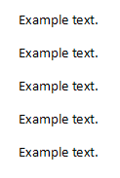
If numbering is applied to the three center paragraphs, the default presentation would have the ListParagraph style applied as well:
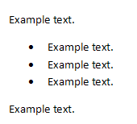
However, if this compatibility setting is turned on:
<w:compat>
<w:useNormalStyleForList />
</w:compat>
Then the new paragraph style shall not be applied, resulting in the following output:
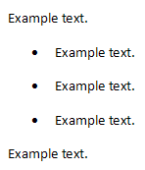
end example]
Parent Elements
compat (§2.15.3.9)

Attributes | Description
val (On/Off Value) | Specifies a binary value for the property defined by the parent XML element.  A value of on, 1, or true specifies that the property shall be explicitly applied. This is the default value for this attribute, and is implied when the parent element is present, but this attribute is omitted.  A value of off, 0, or false specifies that the property shall be explicitly turned off.  [Example: For example, consider the following on/off property:  <w:… w:val="off"/>  The val attribute explicitly declares that the property is turned off. end example]  The possible values for this attribute are defined by the ST_OnOff simple type (§2.18.67).
The following XML Schema fragment defines the contents of this element:
<complexType name="CT_OnOff">
<attribute name="val" type="ST_OnOff"/>
</complexType>

