tblOverlap (Floating Table Allows Other Tables to Overlap)
This element specifies whether the current table shall allow other floating tables to overlap its extents when the tables are displayed in a document. If specified, then no adjustment shall be made to prevent tables whose properties would normally cause them to overlap from overlapping when displayed. If turned off, then the tables shall be adjusted as needed to prevent them from overlapping when displayed by adjusting the floating table properties as needed.
If this element is omitted on a given table, then this table shall allow other tables to overlap when displayed. If the parent table is not floating via the tblpPr element (§2.4.54), then this element shall be ignored.
[Example: Consider two floating tables in a WordprocessingML document which overlap when displayed, as follows:
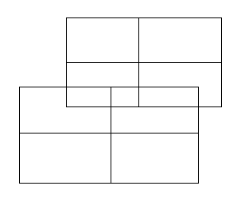
If either of these tables specifies that it shall not allow overlapping, using the following WordprocessingML:
<w:tblPr>
<w:tblOverlap w:val="never"/>
</w:tblPr>
The resulting tables shall not overlap, and must be adjusted at display time to prevent any overlapping, for example:
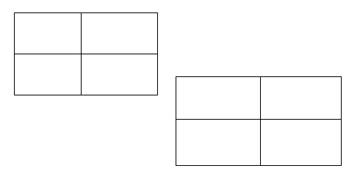
The tblOverlap element with a value of never specifies that the specified table cannot overlap with other floating tables in the document. end example]
Parent Elements
tblPr (§2.7.5.3); tblPr (§2.7.5.4); tblPr (§2.4.55); tblPr (§2.4.56)

Attributes | Description
val (Floating Table Overlap Setting) | Specifies whether a floating table shall allow other floating tables in the document to overlap its extents when displayed.  [Example: The following WordprocessingML specifies that the table is not allowed to overlap:  <w:tblOverlap w:val="never" />  end example]  The possible values for this attribute are defined by the ST_TblOverlap simple type (§2.18.95).
The following XML Schema fragment defines the contents of this element:
<complexType name="CT_TblOverlap">
<attribute name="val" type="ST_TblOverlap" use="required"/>
</complexType>

