tblHeader (Repeat Table Row on Every New Page)
This element specifies that the current table row shall be repeated at the top of each new page on which part of this table is displayed. This gives this table row the behavior of a 'header' row on each of these pages.
If this element is omitted, then the table shall inherit the table cell spacing from the associated table style. If table cell spacing is never specified in the style hierarchy, then this table row shall not be repeated on each new page on which the table is displayed. As well, if this row is not contiguously connected with the first row of the table (that is, if this table row is not either the first row, or all rows between this row and the first row are not marked as header rows) then this property shall be ignored.
[Example: Consider a table which shall have its first row repeated on each new page, like the attribute listings in this Office Open XML Standard, for example:
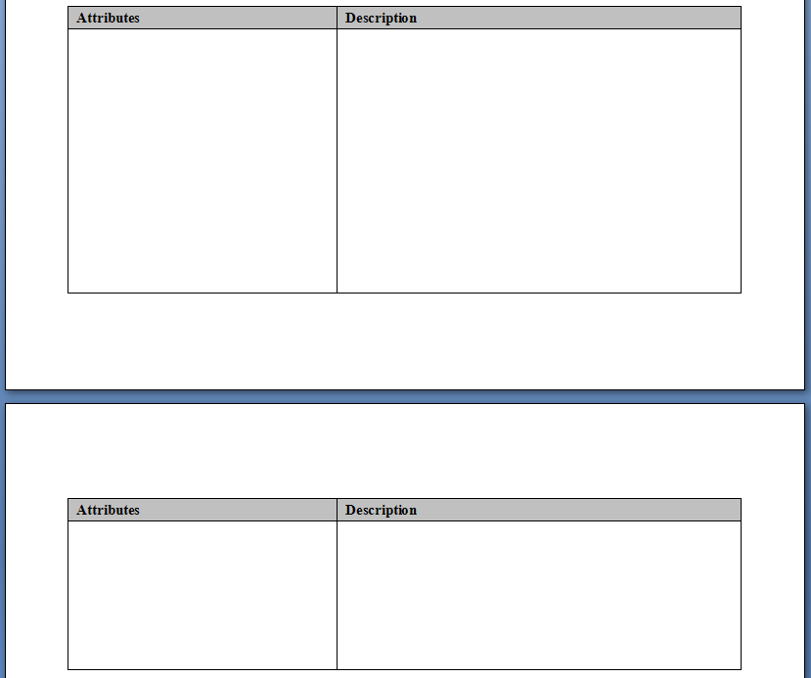
Notice that the first row in the table is repeated on the top of the second page. This requirement would be specified as follows in the WordprocessingML for that row:
<w:trPr>
<w:tblHeader />
</w:trPr>
The tblHeader element specifies that this table row will now be repeated as a header row at the top of each page. end example]
Parent Elements
trPr (§2.7.5.10); trPr (§2.7.5.11); trPr (§2.4.78); trPr (§2.4.79)

Attributes | Description
val (On/Off Value) | Specifies a binary value for the property defined by the parent XML element.  A value of on, 1, or true specifies that the property shall be explicitly applied. This is the default value for this attribute, and is implied when the parent element is present, but this attribute is omitted.  A value of off, 0, or false specifies that the property shall be explicitly turned off.  [Example: For example, consider the following on/off property:  <w:… w:val="off"/>  The val attribute explicitly declares that the property is turned off. end example]  The possible values for this attribute are defined by the ST_OnOff simple type (§2.18.67).
The following XML Schema fragment defines the contents of this element:
<complexType name="CT_OnOff">
<attribute name="val" type="ST_OnOff"/>
</complexType>

