suppressTopSpacingWP (Emulate WordPerfect 5.x Line Spacing)
This element specifies that applications shall emulate the behavior of a previously existing word processing application (WordPerfect 5.x) when determining the resulting spacing between lines in a paragraph using the spacing element (§2.3.1.33). This emulation typically results in line spacing which is reduced from its normal size.
[Guidance: To faithfully replicate this behavior, applications must imitate the behavior of that application, which involves many possible behaviors and cannot be faithfully placed into narrative for this Office Open XML Standard. If applications wish to match this behavior, they must utilize and duplicate the output of those applications. It is recommended that applications not intentionally replicate this behavior as it was deprecated due to issues with its output, and is maintained only for compatibility with existing documents from that application. end guidance]
Typically, applications shall not perform this compatibility. This element, when present with a val attribute value of true (or equivalent), specifies that applications shall attempt to mimic that existing word processing application in this regard.
[Example: Consider a WordprocessingML document with triple line spacing defined using the spacing element:
<w:pPr>
<w:spacing w:line="720" w:lineRule="auto" />
</w:pPr>
If this compatibility setting is turned on:
<w:compat>
<w:suppressTopSpacingWP />
</w:compat>
Then applications should mimic the behavior of WordPerfect 5.x when determining the resulting spacing between each line with additional line spacing, as needed.
As an example of the difference, the output of a normal pairing of triple spaced paragraphs (in black) and one intended to replicate WordPerfect 5.x (in red) is displayed below:
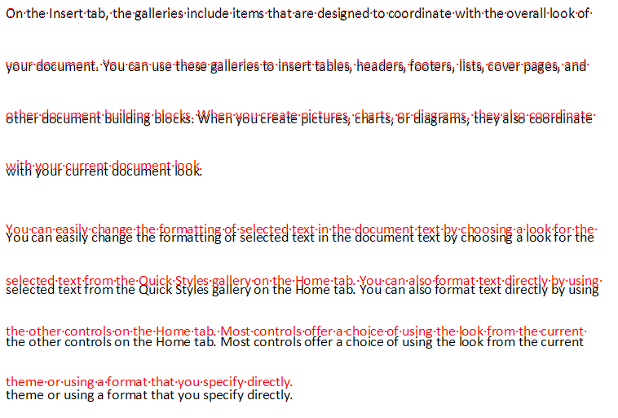
end example]
Parent Elements
compat (§2.15.3.9)

Attributes | Description
val (On/Off Value) | Specifies a binary value for the property defined by the parent XML element.  A value of on, 1, or true specifies that the property shall be explicitly applied. This is the default value for this attribute, and is implied when the parent element is present, but this attribute is omitted.  A value of off, 0, or false specifies that the property shall be explicitly turned off.  [Example: For example, consider the following on/off property:  <w:… w:val="off"/>  The val attribute explicitly declares that the property is turned off. end example]  The possible values for this attribute are defined by the ST_OnOff simple type (§2.18.67).
The following XML Schema fragment defines the contents of this element:
<complexType name="CT_OnOff">
<attribute name="val" type="ST_OnOff"/>
</complexType>

