suppressTopSpacing (Ignore Minimum and Exact Line Height for First Line on Page)
This element specifies whether the minimum line height specified using the spacing element (§2.3.1.33) with a lineRule attribute value of atLeast or exact shall be ignored for the first line on each page.
Typically, if a minimum or exact line height has been specified using the spacing element, then all lines within that paragraph have the necessary line spacing added to them in order to meet this constraint. This element, when present with a val attribute value of true (or equivalent), specifies that no additional spacing shall be added above the first line on each page as a result of these line spacing requirements - the top of the text characters on the first line shall be at the top edge of the page.
[Example: Consider a WordprocessingML document whose first paragraph has a line spacing setting requiring exactly 25 points of space per line:
<w:p>
<w:pPr>
<w:spacing w:line="500" w:lineRule="exact" />
</w:pPr>
…
</w:p>
The default presentation would have the necessary amount of space added between each line such that all lines in the paragraph are centered within 25 points of spacing (highlighting has been added to the image below in order to illustrate the additional spacing above the first line):
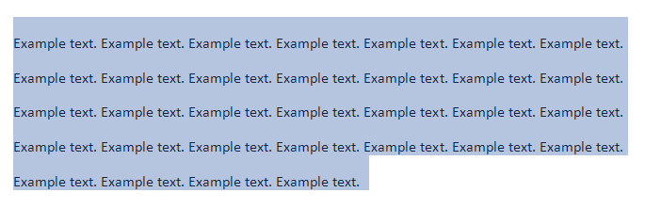
However, if this compatibility setting is turned on:
<w:compat>
<w:suppressTopSpacing />
</w:compat>
Then no additional line spacing shall be added above the first line on the page (although all other lines are unaffected), resulting in the following output:
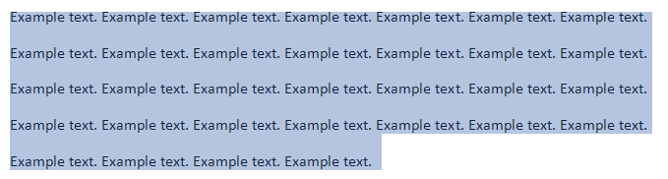
end example]
Parent Elements
compat (§2.15.3.9)

Attributes | Description
val (On/Off Value) | Specifies a binary value for the property defined by the parent XML element.  A value of on, 1, or true specifies that the property shall be explicitly applied. This is the default value for this attribute, and is implied when the parent element is present, but this attribute is omitted.  A value of off, 0, or false specifies that the property shall be explicitly turned off.  [Example: For example, consider the following on/off property:  <w:… w:val="off"/>  The val attribute explicitly declares that the property is turned off. end example]  The possible values for this attribute are defined by the ST_OnOff simple type (§2.18.67).
The following XML Schema fragment defines the contents of this element:
<complexType name="CT_OnOff">
<attribute name="val" type="ST_OnOff"/>
</complexType>

