spaceForUL (Add Additional Space Below Baseline For Underlined East Asian Text)
This element specifies whether East Asian content in a WordprocessingML document which has been underlined using the u element shall have additional descent added to the properties of the font in order to ensure that there is adequate spacing between the characters in the font and the underlining applied to the text.
Typically, no adjustments are made to the contents of text runs containing East Asian text which have been underlined. This element, when present with a val attribute value of true (or equivalent), specifies that whenever the following conditions are met:
- The text run contains East Asian characters
- The text run is not using baseline font alignment as defined by the textAlignment property
That the larger of the following two values will be added to the descent property of that font in order to provide additional padding between the text characters and the underline:
- 3 percent of the font size
- 40 twentieths of a point (31 twentieths of a point for Japanese text)
[Example: Consider a WordprocessingML document consisting of a single run of underlined Japanese text, as follows:
<w:p>
<w:r>
<w:rPr>
<w:u w:type="double" />
</w:rPr>
<w:t>クリスタ</w:t>
</w:r>
</w:p>
If this document is displayed, then the text is laid out along with the underline, as follows:
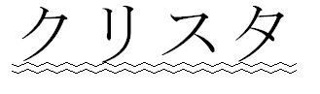
However, if this compatibility setting is turned on:
<w:compat>
<w:spaceForUL />
</w:compat>
Then the additional descent specified using the logic above is added to the text, resulting in the following output:
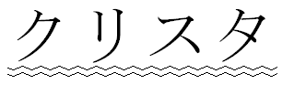
end example]
Parent Elements
compat (§2.15.3.9)

Attributes | Description
val (On/Off Value) | Specifies a binary value for the property defined by the parent XML element.  A value of on, 1, or true specifies that the property shall be explicitly applied. This is the default value for this attribute, and is implied when the parent element is present, but this attribute is omitted.  A value of off, 0, or false specifies that the property shall be explicitly turned off.  [Example: For example, consider the following on/off property:  <w:… w:val="off"/>  The val attribute explicitly declares that the property is turned off. end example]  The possible values for this attribute are defined by the ST_OnOff simple type (§2.18.67).
The following XML Schema fragment defines the contents of this element:
<complexType name="CT_OnOff">
<attribute name="val" type="ST_OnOff"/>
</complexType>

