sourceFileName (Source File for Frame)
This element specifies the ID for the relationship which specifies the source file for a single frame within a frameset document.
The relationship referenced by this element's id attribute shall exist in the relationship part item for the Web Settings part,or this document shall be considered non-conformant. Also, the type of the relationship referenced by this element's id attribute shall be http://schemas.openxmlformats.org/officeDocument/2006/relationships/frame, or this document shall be considered non-conformant.
If this element is omitted, then no source file is present for the current frame, and one may be created dynamically as needed to display content within the frame.
[Example: Consider a WordprocessingML document which serves as the frameset container for a frameset consisting of the following three frames:
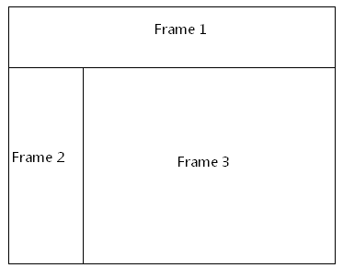
The frameset properties for this document are specified by the following WordprocessingML within the web page settings:
<w:frameset>
…
<w:frameset>
…
<w:frame>
<w:name w:val="Frame 2" />
<w:sourceFileName r:id="rId5" />
</w:frame>
…
</w:frameset>
</w:frameset>
The sourceFileName element specifies that the contents of this frame shall be the contents of the file targeted by the relationship with ID rId5 in the web settings part's relationship part item. end example]
Parent Elements
frame (§2.15.2.16)

Attributes | Description
id (Relationship to Part)  Namespace: .../officeDocument/2006/relationships | Specifies the relationship ID to a specified part.  The specified relationship shall match the type required by the parent element:  - http://schemas.openxmlformats.org/officeDocument/2006/relationships/footer for the footerReference element  - http://schemas.openxmlformats.org/officeDocument/2006/relationships/header for the headerReference element  - http://schemas.openxmlformats.org/officeDocument/2006/relationships/font for the embedBold, embedBoldItalic, embedItalic, or embedRegular elements  - http://schemas.openxmlformats.org/officeDocument/2006/relationships/printerSettings for the printerSettings element  [Example: Consider an XML element which has the following id attribute:  <… r:id="rId10" />  The markup specifies the associated relationship part with relationship ID rId1 contains the corresponding relationship information for the parent XML element. end example]  The possible values for this attribute are defined by the ST_RelationshipId simple type (§7.8.2.1).
The following XML Schema fragment defines the contents of this element:
<complexType name="CT_Rel">
<attribute ref="r:id" use="required"/>
</complexType>

