selectFldWithFirstOrLastChar (Select Field When First or Last Character Is Selected)
This element specifies whether applications should automatically select the entire contents of a field in a WordprocessingML document when the first or last character is selected.
Typically, users can select any character individually within the result of a field in the document. This element, when present with a val attribute value of true (or equivalent), specifies that selecting the first or last character of that field result shall automatically result in the selection of the entire field.
[Example: Consider a WordprocessingML document which contains the following (with a field marked in gray shading):
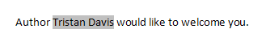
The default presentation would allow the first character of that field to be selected:
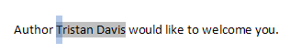
However, if this compatibility setting is turned on:
<w:compat>
<w:selectFldWithFirstOrLastChar />
</w:compat>
Then that selection would automatically result in the entire field being selected, resulting in the following:
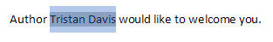
end example]
Parent Elements
compat (§2.15.3.9)

Attributes | Description
val (On/Off Value) | Specifies a binary value for the property defined by the parent XML element.  A value of on, 1, or true specifies that the property shall be explicitly applied. This is the default value for this attribute, and is implied when the parent element is present, but this attribute is omitted.  A value of off, 0, or false specifies that the property shall be explicitly turned off.  [Example: For example, consider the following on/off property:  <w:… w:val="off"/>  The val attribute explicitly declares that the property is turned off. end example]  The possible values for this attribute are defined by the ST_OnOff simple type (§2.18.67).
The following XML Schema fragment defines the contents of this element:
<complexType name="CT_OnOff">
<attribute name="val" type="ST_OnOff"/>
</complexType>

