pos (Footnote Placement)
This element specifies where footnotes shall be placed on the page when they are referenced by text in the current document.
If this element is present at the section level, then it shall be ignored.
If this element is omitted at the document level, then footnotes shall be located at the bottom of the current page.
[Example: Consider the following one page document, where the footnote appears beneath the text that it is referencing:
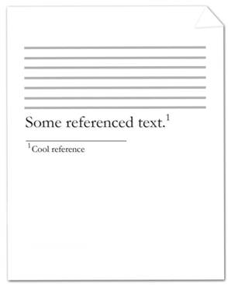
The footnote references the text reading Some reference text. and is represented by the following WordprocessingML:
<w:p>
<w:r>
<w:t>Some referenced text</w:t>
</w:r>
<w:r>
<w:rPr>
<w:rStyle w:val="FootnoteReference" />
</w:rPr>
<w:footnoteReference w:id="2" />
</w:r>
</w:p>
Since the footnote location must be beneath the current text, the section properties shall be declared as follows:
<w:settings>
…
<w:footnotePr>
<w:pos w:val="beneathText" />
</w:footnotePr>
…
</w:sectPr>
The footnote references the footnote in the footnotes part with an id attribute value equal to 2. Within the section properties of the document, the position of footnotes is specified to be beneath the page's text. end example]
Parent Elements
footnotePr (§2.11.11); footnotePr (§2.11.12)

Attributes | Description
val (Footnote Position Type) | Specifies the position of footnotes in the document.  [Example: Consider a document in which footnotes shall be positioned beneath their text. The footnote properties for this document shall be declared as follows:  <w:sectPr>  <w:footnotePr>  <w:pos w:val="beneathText" />  </w:footnotePr>  …  </w:sectPr>  The val attribute is beneathText, therefore the position of footnotes is specified to be beneath the page's text. end example]  The possible values for this attribute are defined by the ST_FtnPos simple type (§2.18.38).
The following XML Schema fragment defines the contents of this element:
<complexType name="CT_FtnPos">
<attribute name="val" type="ST_FtnPos" use="required"/>
</complexType>

