numRestart (Footnote and Endnote Numbering Restart Location)
This element specifies when all automatic numbering for the footnote or endnote reference marks shall be restarted. When restarted, the next automatically numbered footnote or endnote in the document (each type is handled independently) shall restart to the specified numStart value (§2.11.20).
If this element is omitted, then automatic numbering shall not be restarted between each page or section (a vlaue of continuous).
[Example: Consider the following two page document where the numbering shall be reset after each page to its starting value:
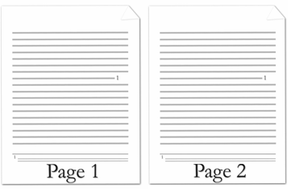
The footnote automatic restarting of the numbering is represented by the following WordprocessingML:
<w:footnotePr>
<w:numRestart w:val="eachPage" />
</w:footnotePr>
end example]
Parent Elements
endnotePr (§2.11.4); endnotePr (§2.11.5); footnotePr (§2.11.11); footnotePr (§2.11.12)

Attributes | Description
val (Automatic Numbering Restart Value) | Specifies when the automatic numbering shall be restarted for the current set of footnotes or endnotes.  [Example: Consider a WordprocessingML document where the numbering for its endnotes shall be restarted after each section shall be restarted after each page. This setting is represented by the following WordprocessingML:  <w:footnotePr>  <w:numRestart w:val="eachSect" />  </w:footnotePr>  The val attribute value of eachSect specifies that numbering shal be restarted after each section. end example]  The possible values for this attribute are defined by the ST_RestartNumber simple type (§2.18.81).
The following XML Schema fragment defines the contents of this element:
<complexType name="CT_NumRestart">
<attribute name="val" type="ST_RestartNumber" use="required"/>
</complexType>

