noResizeAllowed (Frame Cannot Be Resized)
This element specifies whether or not the size of the current frame shall be modifiable (i.e. whether the frame can be resized) when the contents of this document are saved as HTML and displayed in a web browser. When this element is set, the size of the frame shall be set to its current values. This property is analogous to the noresize attribute on the frame element in HTML.
If this element is omitted, the size of the frame shall be modifiable (the frame may be resized when it is displayed).
[Example: Consider a WordprocessingML document which serves as the frameset container for a frameset consisting of the following three frames:
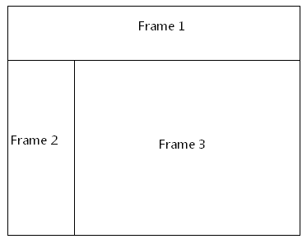
The frameset properties for this document are specified by the following WordprocessingML within the web page settings:
<w:frameset>
…
<w:frameset>
…
<w:frame>
<w:name w:val="Frame 2" />
<w:noResizeAllowed w:val="true" />
</w:frame>
…
</w:frameset>
</w:frameset>
The noResizeAllowed element has a val attribute of true, which specifies that the size of the frame specified by Frame 2 shall not be modifiable (the two borders which intersect that frame cannot be resized). end example]
Parent Elements
frame (§2.15.2.16)

Attributes | Description
val (On/Off Value) | Specifies a binary value for the property defined by the parent XML element.  A value of on, 1, or true specifies that the property shall be explicitly applied. This is the default value for this attribute, and is implied when the parent element is present, but this attribute is omitted.  A value of off, 0, or false specifies that the property shall be explicitly turned off.  [Example: For example, consider the following on/off property:  <w:… w:val="off"/>  The val attribute explicitly declares that the property is turned off. end example]  The possible values for this attribute are defined by the ST_OnOff simple type (§2.18.67).
The following XML Schema fragment defines the contents of this element:
<complexType name="CT_OnOff">
<attribute name="val" type="ST_OnOff"/>
</complexType>

