noBorder (Do Not Display Frameset Splitters)
This element specifies whether the splitters shall be displayed for the contents of the frameset in this WordprocessingML document. This element shall only be honored on the root frameset for this document, and may be ignored for all nested framesets in this document. If this element is present, then no splitters shall be displayed, and all other frameset splitter properties may be ignored.
If this element is omitted, then the splitters in this document shall be displayed as defined by the w and color elements.
[Example: Consider a frameset consisting of the following three frames:
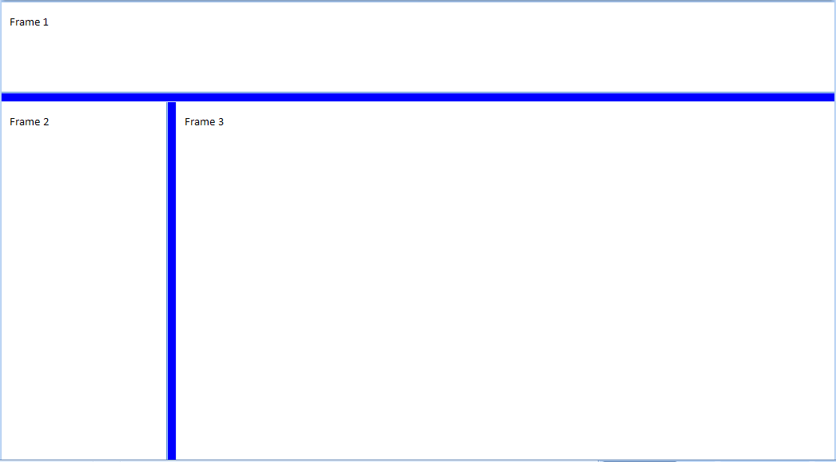
The following properties define the presentation of the splitter bars within this frameset:
<w:frameset>
<w:framesetSplitbar>
<w:w w:val="200" />
<w:color w:val="0000FF" />
</w:framesetSplitbar>
…
</w:frameset>
If the noBorder element is also specified:
<w:frameset>
<w:framesetSplitbar>
<w:w w:val="200" />
<w:color w:val="0000FF" />
<w:noBorder w:val="true" />
</w:framesetSplitbar>
…
</w:frameset>
Then all frameset splitters are suppressed:
The noBorder element's val attribute has a value of true, which specifies that the splitters for this document shall not be displayed. end example]
Parent Elements
framesetSplitbar (§2.15.2.20)

Attributes | Description
val (On/Off Value) | Specifies a binary value for the property defined by the parent XML element.  A value of on, 1, or true specifies that the property shall be explicitly applied. This is the default value for this attribute, and is implied when the parent element is present, but this attribute is omitted.  A value of off, 0, or false specifies that the property shall be explicitly turned off.  [Example: For example, consider the following on/off property:  <w:… w:val="off"/>  The val attribute explicitly declares that the property is turned off. end example]  The possible values for this attribute are defined by the ST_OnOff simple type (§2.18.67).
The following XML Schema fragment defines the contents of this element:
<complexType name="CT_OnOff">
<attribute name="val" type="ST_OnOff"/>
</complexType>

