name (Frame Name)
This element specifies the name of a single frame within a frameset document. This property is analogous to the name attribute on the frame element in HTML.
[Note: The name of a frame may be used in web pages that reference a frame via targeted links, etc. end note]
If this element is omitted, then the current frame shall have no name associated with it.
[Example: Consider a WordprocessingML document which serves as the frameset container for a frameset consisting of the following three frames:
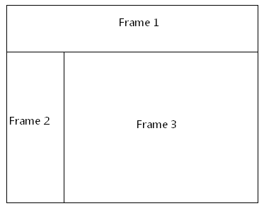
The frameset properties for this document are specified by the following WordprocessingML within the web page settings:
<w:frameset>
…
<w:frame>
<w:name w:val="Frame 1" />
</w:frame>
<w:frameset>
…
<w:frame>
<w:name w:val="Frame 2" />
</w:frame>
<w:frame>
<w:name w:val="Frame 3" />
</w:frame>
</w:frameset>
</w:frameset>
The name element specifies the name for each frame within this frameset; in this case, the frames have names of Frame 1, Frame 2, and Frame 3 respectively. end example]
Parent Elements
frame (§2.15.2.16)

Attributes | Description
val (String Value) | Specifies that its contents will contain a string.  The contents of this string are interpreted based on the context of the parent XML element.  [Example: Consider the following WordprocessingML fragment:  <w:pPr>  <w:pStyle w:val="heading1" />  </w:pPr>  The value of the val attribute is the ID of the associated paragraph style's styleId.  However, consider the following fragment:  <w:sdtPr>  <w:alias w:val="SDT Title Example" />  ...  </w:sdtPr>  In this case, the decimal number in the val attribute is the caption of the parent structured document tag. In each case, the value is interpreted in the context of the parent element. end example]  The possible values for this attribute are defined by the ST_String simple type (§2.18.89).
The following XML Schema fragment defines the contents of this element:
<complexType name="CT_String">
<attribute name="val" type="ST_String" use="required"/>
</complexType>

