mwSmallCaps (Emulate Word 5.x for the Macintosh Small Caps Formatting)
This element specifies that applications shall emulate the behavior of a previously existing word processing application (Microsoft Word 5.x for the Macintosh) when determining the resulting formatting when the smallCaps element (§2.3.2.31) is applied to runs of text within this WordprocessingML document. This emulation typically results in small caps which are smaller than typical small caps at most font sizes.
[Guidance: To faithfully replicate this behavior, applications must imitate the behavior of that application, which involves many possible behaviors and cannot be faithfully placed into narrative for this Office Open XML Standard. If applications wish to match this behavior, they must utilize and duplicate the output of those applications. It is recommended that applications not intentionally replicate this behavior as it was deprecated due to issues with its output, and is maintained only for compatibility with existing documents from that application. end guidance]
Typically, applications shall not perform this compatibility. This element, when present with a val attribute value of true (or equivalent), specifies that applications shall attempt to mimic that existing word processing application in this regard.
[Example: Consider a WordprocessingML document with small caps on its text contents.
If this compatibility setting is turned on:
<w:compat>
<w:mwSmallCaps />
</w:compat>
Then applications should mimic the behavior of Microsoft Word 5.x for the Macintosh when determining the formatting for small caps of characters which specify this formatting, as needed.
As an example of the typical differences, the output of a normal small caps implementation (in black) and one intended to replicate Word 5.x for the Macintosh (in red) are displayed below for several font sizes:
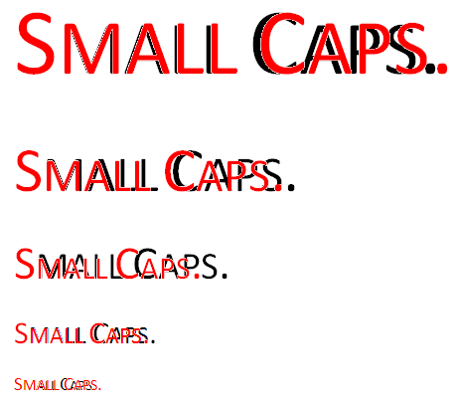
end example]
Parent Elements
compat (§2.15.3.9)

Attributes | Description
val (On/Off Value) | Specifies a binary value for the property defined by the parent XML element.  A value of on, 1, or true specifies that the property shall be explicitly applied. This is the default value for this attribute, and is implied when the parent element is present, but this attribute is omitted.  A value of off, 0, or false specifies that the property shall be explicitly turned off.  [Example: For example, consider the following on/off property:  <w:… w:val="off"/>  The val attribute explicitly declares that the property is turned off. end example]  The possible values for this attribute are defined by the ST_OnOff simple type (§2.18.67).
The following XML Schema fragment defines the contents of this element:
<complexType name="CT_OnOff">
<attribute name="val" type="ST_OnOff"/>
</complexType>

