marW (Left and Right Margin for Frame)
This element specifies the left and right margin height for a single frame in a frameset document, as follows:
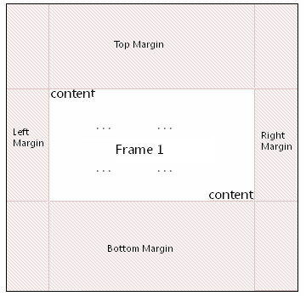
This height is expressed in pixels.
If this element is omitted, then no left or right margin shall be used for this frame.
[Example: Consider a document that has a frame, where the frame's margins have been specified and is represented as the following WordprocessingML:
<w:frame>
<w:marW w:val="294"/>
</w:frame>
The marW element has a val attribute value of 294, which specifies that this frame has a left and right margin value of 294 pixels, resulting in 294 pixels of space between the content and the left and right margins of the frame. end example]
Parent Elements
frame (§2.15.2.16)

Attributes | Description
val (Measurement in Pixels) | Specifies a value whose contents shall contain a positive whole number, whose contents consist of a positive measurement in pixels.  The contents of this measurement shall be interpreted based on the context of the parent XML element.  [Example: Consider an attribute value of 960 whose type is ST_PixelsMeasure. This attribute value specifies a value of 960 pixels. end example]  The possible values for this attribute are defined by the ST_PixelsMeasure simple type (§2.18.74).
The following XML Schema fragment defines the contents of this element:
<complexType name="CT_PixelsMeasure">
<attribute name="val" type="ST_PixelsMeasure" use="required"/>
</complexType>

