linkedToFile (Maintain Link to Existing File)
This element specifies that the file referenced by the sourceFileName element (§2.15.2.38) as the basis for the current frame shall not be changed, even when the file defined by the parent frameset is moved - i.e. the link shall remain exactly as specified.
[Guidance: Typically, when a document is incorporated into a frameset, a copy of that document is made such that all files encompassing the frameset are stored in a single subdirectory (so they can be moved as a single unit). However, if the link to the current file is absolute and shall not be changed even when the location of the main frameset document, then this element shall be set to indicate that setting. end guidance]
If this element is omitted, then a new file may be created as necessary when the parent frameset document is resaved to another location.
[Example: Consider a WordprocessingML document which serves as the frameset container for a frameset consisting of the following three frames:
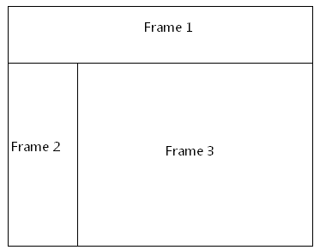
The frameset properties for this document are specified by the following WordprocessingML within the web page settings:
<w:frameset>
…
<w:frame>
<w:sz w:val="20%" />
<w:name w:val="Frame 1" />
<w:sourceFileName r:id="rId1" />
<w:linkedToFile w:val="true" />
</w:frame>
<w:frameset>
…
</w:frameset>
</w:frameset>
The linkedToFile element specifies that the frame source location specified by the sourceFileName element (§2.15.2.38) shall not be modified, even if the parent frameset document is resaved to another location. end example]
Parent Elements
frame (§2.15.2.16)

Attributes | Description
val (On/Off Value) | Specifies a binary value for the property defined by the parent XML element.  A value of on, 1, or true specifies that the property shall be explicitly applied. This is the default value for this attribute, and is implied when the parent element is present, but this attribute is omitted.  A value of off, 0, or false specifies that the property shall be explicitly turned off.  [Example: For example, consider the following on/off property:  <w:… w:val="off"/>  The val attribute explicitly declares that the property is turned off. end example]  The possible values for this attribute are defined by the ST_OnOff simple type (§2.18.67).
The following XML Schema fragment defines the contents of this element:
<complexType name="CT_OnOff">
<attribute name="val" type="ST_OnOff"/>
</complexType>

