hdr (Header)
This element specifies the content for a single header for use within one or more sections of a WordprocessingML document.
Within the hdr element, the content of the element is similar to the content of the body (§2.2.2) element, and contains what is referred to as block-level markup - markup which can exist as a sibling element to paragraphs in a WordprocessingML document.
[Example: Consider the following simple one page document with one header:
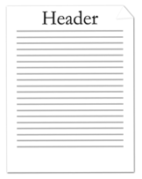
This document defines one header with the text Header. The header's contents is stored in a unique Header part. The resulting header is represented by the following WordprocessingML:
<w:hdr>
<w:p>
<w:r>
<w:t>Header</w:t>
</w:r>
</w:p>
</w:hdr>
Since headers are containers of block level contents, all block level elements can be used within them. In this particular example, the content is a single paragraph. end example]
[Example: Consider a more complex three page document with different first, odd, and even page headers defined:
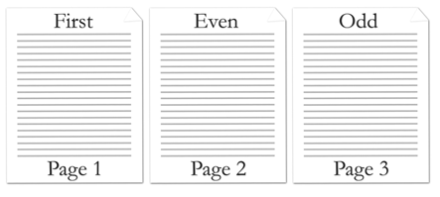
This document defines three headers stored in three different header parts. The resulting headers are represented by the following WordprocessingML:
First page header part:
<w:hdr>
<w:p>
<w:r>
<w:t>First</w:t>
</w:r>
</w:p>
</w:hdr>
Even page header part:
<w:hdr>
<w:p>
<w:r>
<w:t>Even</w:t>
</w:r>
</w:p>
</w:hdr>
Odd page header part:
<w:hdr>
<w:p>
<w:r>
<w:t>Odd</w:t>
</w:r>
</w:p>
</w:hdr>
end example]
Parent Elements
Root element of WordprocessingML Header part

Child Elements | Subclause
altChunk (Anchor for Imported External Content) | §2.17.3.1
bookmarkEnd (Bookmark End) | §2.13.6.1
bookmarkStart (Bookmark Start) | §2.13.6.2
commentRangeEnd (Comment Anchor Range End) | §2.13.4.3
commentRangeStart (Comment Anchor Range Start) | §2.13.4.4
customXml (Block-Level Custom XML Element) | §2.5.1.6
customXmlDelRangeEnd (Custom XML Markup Deletion End) | §2.13.5.4
customXmlDelRangeStart (Custom XML Markup Deletion Start) | §2.13.5.5
customXmlInsRangeEnd (Custom XML Markup Insertion End) | §2.13.5.6
customXmlInsRangeStart (Custom XML Markup Insertion Start) | §2.13.5.7
customXmlMoveFromRangeEnd (Custom XML Markup Move Source End) | §2.13.5.8
customXmlMoveFromRangeStart (Custom XML Markup Move Source Start) | §2.13.5.9
customXmlMoveToRangeEnd (Custom XML Markup Move Destination Location End) | §2.13.5.10
customXmlMoveToRangeStart (Custom XML Markup Move Destination Location Start) | §2.13.5.11
del (Deleted Run Content) | §2.13.5.12
ins (Inserted Run Content) | §2.13.5.20
moveFrom (Move Source Run Content) | §2.13.5.21
moveFromRangeEnd (Move Source Location Container - End) | §2.13.5.23
moveFromRangeStart (Move Source Location Container - Start) | §2.13.5.24
moveTo (Move Destination Run Content) | §2.13.5.26
moveToRangeEnd (Move Destination Location Container - End) | §2.13.5.27
moveToRangeStart (Move Destination Location Container - Start) | §2.13.5.28
oMath (Office Math) | §7.1.2.77
oMathPara (Math Paragraph) | §7.1.2.78
p (Paragraph) | §2.3.1.22
permEnd (Range Permission End) | §2.13.7.1
permStart (Range Permission Start) | §2.13.7.2
proofErr (Proofing Error Anchor) | §2.13.8.1
sdt (Block-Level Structured Document Tag) | §2.5.2.30
tbl (Table) | §2.4.36
The following XML Schema fragment defines the contents of this element:
<complexType name="CT_HdrFtr">
<group ref="EG_BlockLevelElts" minOccurs="1" maxOccurs="unbounded"/>
</complexType>

