growAutofit (Allow Tables to AutoFit Into Page Margins)
This element specifies whether applications shall allow a table which is using the AutoFit table layout algorithm to extend beyond the margins of the page if the minimum width of each table cell would result in an overall table width which is wider than those page margins.
Typically, if a table is using the AutoFit layout algorithm, then based on the definition of that logic, each column in the table shall be increased to the minimum width of its contents (e.g. the longest non-breaking run of text contained within it and/or the width of an inline image contained in one of its cells) until the overall width of the table reaches that of the text extents on the page, at which point text shall be broken and images shall be clipped as needed to maintain the width of the table at the page width (i.e. the page width is an immutable maximum width for the table). This element, when present with a val attribute value of true (or equivalent), specifies that the minimum width of the cells shall not be constrained by the page width, and instead the table shall be allowed to extend into the page margins as needed in order to meet the minimum widths of each of its cells.
[Example: Consider a WordprocessingML table with three cells in each row. If the contents of each cell in that first row each contain a long non-breaking string (such that the minimum widths of each cell's contents exceed the page width), then the rules for table AutoFit specify that each cell must be broken proportionally when the overall width of the table reaches the page width.
The default presentation of this document results in each cell being broken as needed to maintain the table width, as follows:
However, if this compatibility setting is turned on:
<w:compat>
<w:growAutofit />
</w:compat>
Then the presence of those long non-breaking strings (and the resulting large minimum widths for each table cell) shall result in a table width which is then allowed to override the page margins, resulting in the following output:
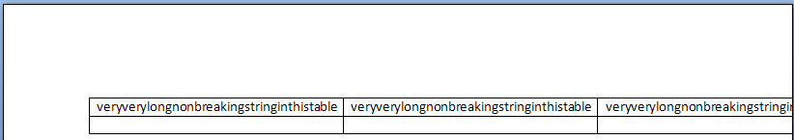
The resulting table is clipped by the edge of the page on its right side, but the minimum widths of each cell are maintained as defined by the long non-breaking string contents of each. end example]
Parent Elements
compat (§2.15.3.9)

Attributes | Description
val (On/Off Value) | Specifies a binary value for the property defined by the parent XML element.  A value of on, 1, or true specifies that the property shall be explicitly applied. This is the default value for this attribute, and is implied when the parent element is present, but this attribute is omitted.  A value of off, 0, or false specifies that the property shall be explicitly turned off.  [Example: For example, consider the following on/off property:  <w:… w:val="off"/>  The val attribute explicitly declares that the property is turned off. end example]  The possible values for this attribute are defined by the ST_OnOff simple type (§2.18.67).
The following XML Schema fragment defines the contents of this element:
<complexType name="CT_OnOff">
<attribute name="val" type="ST_OnOff"/>
</complexType>

