frame (Single Frame Properties)
This element specifies the properties for a single frame within a frameset document. When a document defines a frameset using the frameset element; that frameset is composed of a set of frames, each of which is specified by a single frame element.
[Example: Consider a WordprocessingML document which serves as the frameset container for a frameset consisting of the following three frames:
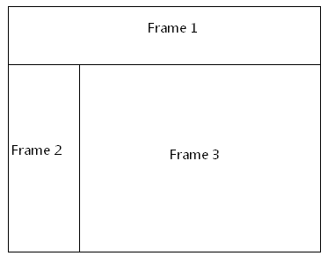
The frameset properties for this document are specified by the following WordprocessingML within the web page settings:
<w:frameset>
…
<w:frame>
<w:sz w:val="20%" />
<w:name w:val="Frame 1" />
<w:sourceFileName r:id="rId1" />
</w:frame>
<w:frameset>
…
</w:frameset>
</w:frameset>
The frame element specifies the set of properties for a single frame in the document. In this case, these properties (for the frame marked with Frame 1 in the diagram above) specify that the frame shall have the following properties:
- A height of 20% of the height of the document
- A name of Frame 1
- The contents of the frame shall be pulled from the document that is the target of the relationship with ID rId1
end example]
Parent Elements
frameset (§2.15.2.18); frameset (§2.15.2.19)

Child Elements | Subclause
linkedToFile (Maintain Link to Existing File) | §2.15.2.22
marH (Top and Bottom Margin for Frame) | §2.15.2.24
marW (Left and Right Margin for Frame) | §2.15.2.28
name (Frame Name) | §2.15.2.29
noResizeAllowed (Frame Cannot Be Resized) | §2.15.2.31
scrollbar (Scrollbar Display Option) | §2.15.2.37
sourceFileName (Source File for Frame) | §2.15.2.38
sz (Frame Size) | §2.15.2.39
The following XML Schema fragment defines the contents of this element:
<complexType name="CT_Frame">
<sequence>
<element name="sz" type="CT_String" minOccurs="0"/>
<element name="name" type="CT_String" minOccurs="0"/>
<element name="sourceFileName" type="CT_Rel" minOccurs="0"/>
<element name="marW" type="CT_PixelsMeasure" minOccurs="0"/>
<element name="marH" type="CT_PixelsMeasure" minOccurs="0"/>
<element name="scrollbar" type="CT_FrameScrollbar" minOccurs="0"/>
<element name="noResizeAllowed" type="CT_OnOff" minOccurs="0"/>
<element name="linkedToFile" type="CT_OnOff" minOccurs="0"/>
</sequence>
</complexType>

