footnoteRef (Footnote Reference Mark)
This element specifies the presence of a footnote reference mark. A footnote reference mark is a run of automatically numbered text which follows the numbering format set forth via the footnote numFmt element (§2.11.17).
If a footnote reference mark is specified within a run which is not part of a footnote, then that footnote reference mark may be ignored.
[Example: Consider the following document where some text is referenced by an footnote at the end of the page:
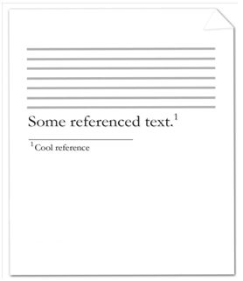
The footnote reference mark is the decimal number within the actual footnote itself in the image above. The contents of the footnote (including the footnote reference mark) are represented by the following WordprocessingML:
<w:footnote w:id="2">
<w:p>
<w:pPr>
<w:pStyle w:val="FootnoteText" />
</w:pPr>
<w:r>
<w:rPr>
<w:rStyle w:val="FootnoteReference" />
</w:rPr>
<w:footnoteRef />
</w:r>
<w:r>
<w:t>Cool reference</w:t>
</w:r>
</w:p>
</w:footnote>
The resulting footnote contains the literal endnote content of Cool reference, preceding by an automatically numbered footnote reference mark. Since this is the first footnote in the document, that automatically numbered reference mark uses the first decimal number 1. It is also important to note that the use of styles FootnoteText and FootnoteReference is not required, these may simply be added by a particular producer automatically to give the footnote contents are particular style (just like any other use of styles). end example]
Parent Elements
r (§7.1.2.87); r (§2.3.2.23)
The following XML Schema fragment defines the contents of this element:
<complexType name="CT_Empty"/>

