footnotePr (Document-Wide Footnote Properties)
This element specifies the footnote properties for this document. Each property is stored as a unique element within the footnotePr element.
These properties may be overridden for a specific section via the section-wide footnotePr element (§2.11.12).
[Example: Consider the following one page document, where the footnote appears beneath the text it references:
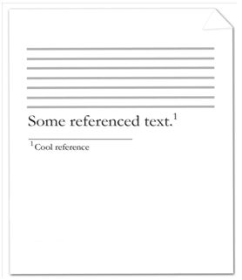
Since the document consists of a single footnote, the footnote properties may be stored in either the section-wide or document-wide footnote properties. Assuming that they are stored in the latter, the footnote properties are represented by the following WordprocessingML:
<w:settings>
…
<w:footnotePr>
<w:pos w:val="beneathText" />
</w:footnotePr>
…
</w:settings>
The footnote properties specify that footnotes will appear below the noted text end example]
Parent Elements
settings (§2.15.1.78)

Child Elements | Subclause
footnote (Special Footnote List) | §2.11.9
numFmt (Footnote Numbering Format) | §2.11.17
numRestart (Footnote and Endnote Numbering Restart Location) | §2.11.19
numStart (Footnote and Endnote Numbering Starting Value) | §2.11.20
pos (Footnote Placement) | §2.11.21
The following XML Schema fragment defines the contents of this element:
<complexType name="CT_FtnDocProps">
<complexContent>
<extension base="CT_FtnProps">
<sequence>
<element name="footnote" type="CT_FtnEdnSepRef" minOccurs="0" maxOccurs="3"/>
</sequence>
</extension>
</complexContent>
</complexType>

