flatBorders (Frameset Splitter Border Style)
This element specifies the 3D style of the splitters within the frameset in this WordprocessingML document. This element shall only be honored on the root frameset for this document, and may be ignored for all nested framesets in this document. When this property is turned on, the borders for this frameset shall be flat (not 3D), otherwise they may be presented as 3D splitter when they are displayed.
If this element is omitted, then the default style of the splitter should be a 3D splitter.
[Example: Consider a frameset consisting of the following three frames:
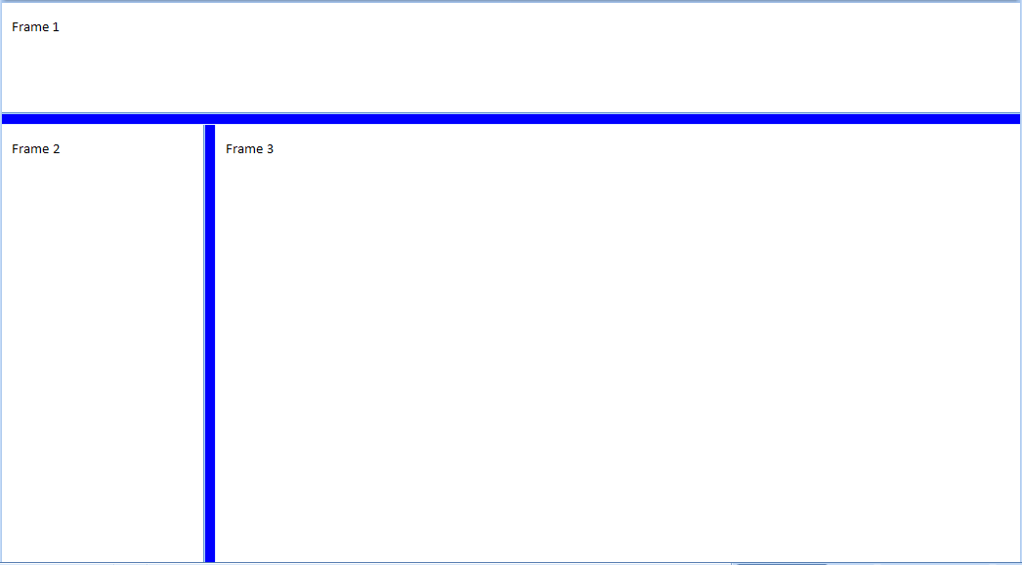
The following properties define the presentation of the splitter bars within this frameset:
<w:frameset>
<w:framesetSplitbar>
<w:w w:val="200" />
<w:color w:val="0000FF" />
<w:flatBorders w:val="true" />
</w:framesetSplitbar>
…
</w:frameset>
The flatBorders element's val attribute has a value of true, which specifies that the style of the splitters shall be flat (the splitter may not be 3D when displayed). end example]
Parent Elements
framesetSplitbar (§2.15.2.20)

Attributes | Description
val (On/Off Value) | Specifies a binary value for the property defined by the parent XML element.  A value of on, 1, or true specifies that the property shall be explicitly applied. This is the default value for this attribute, and is implied when the parent element is present, but this attribute is omitted.  A value of off, 0, or false specifies that the property shall be explicitly turned off.  [Example: For example, consider the following on/off property:  <w:… w:val="off"/>  The val attribute explicitly declares that the property is turned off. end example]  The possible values for this attribute are defined by the ST_OnOff simple type (§2.18.67).
The following XML Schema fragment defines the contents of this element:
<complexType name="CT_OnOff">
<attribute name="val" type="ST_OnOff"/>
</complexType>

