endnotePr (Document-Wide Endnote Properties)
This element specifies the endnote properties for the current document. Each of these properties are stored as a child element within the endnotePr element.
These properties may be overridden for a specific section via the section-wide endnotePr element (§2.11.5).
[Example: Consider the following document with two sections, where the endnotes for each section appears at the end of that section and use lower case roman numerals:
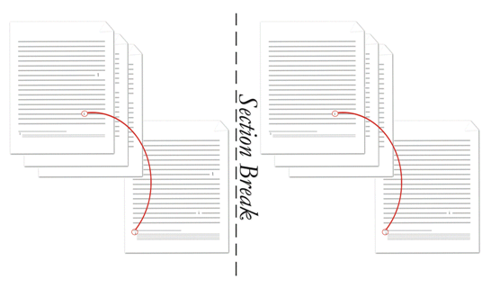
Since both sections are identical, the endnote properties are specified as document-wide level properties (this is not necessary but is most efficient) as follows:
<w:settings>
…
<w:endnotePr>
<w:numFmt w:val="lowerRoman" />
<w:pos w:val="sectEnd"/>
</w:endnotePr>
…
</w:settings>
Note that the pos element could have been omitted since it is using its default value. end example]
Parent Elements
settings (§2.15.1.78)

Child Elements | Subclause
endnote (Special Endnote List) | §2.11.3
numFmt (Endnote Numbering Format) | §2.11.18
numRestart (Footnote and Endnote Numbering Restart Location) | §2.11.19
numStart (Footnote and Endnote Numbering Starting Value) | §2.11.20
pos (Endnote Placement) | §2.11.22
The following XML Schema fragment defines the contents of this element:
<complexType name="CT_EdnDocProps">
<complexContent>
<extension base="CT_EdnProps">
<sequence>
<element name="endnote" type="CT_FtnEdnSepRef" minOccurs="0" maxOccurs="3"/>
</sequence>
</extension>
</complexContent>
</complexType>

