doNotWrapTextWithPunct (Do Not Allow Hanging Punctuation With Character Grid)
This element specifies whether applications shall allowing hanging punctuation when:
- The overflowPunct element (§2.3.1.21) is turned on for a paragraph
- A document grid is defined using the docGrid element (§2.6.5) which defines the number of characters per line
Typically, paragraphs which allow hanging punctuation shall allow the number of characters on a line as specified by the document grid to be exceeded by one in order to allow for hanging punctuation. This element, when present with a val attribute value of true (or equivalent), specifies that the document grid shall never be exceeded for hanging punctuation.
[Example: Consider a WordprocessingML document with a document grid set to allow 10 characters per line:
<w:sectPr>
<w:docGrid w:type="snapToChars" w:charSpace="146636" … />
</w:sectPr>
If the eleventh character on the line was a punctuation characters, the default presentation would allow that character to behave as hanging punctuation on the first line:
However, if this compatibility setting is turned on:
<w:compat>
<w:wrapTextWithPunct />
</w:compat>
Then the character grid cannot be exceeded even for the hanging punctuation, resulting in the following output:
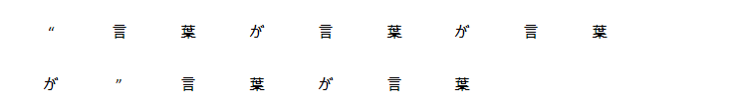
The hanging punctuation was disallowed, moving it (and the character before it, since that character cannot begin a line) to the following line. end example]
Parent Elements
compat (§2.15.3.9)

Attributes | Description
val (On/Off Value) | Specifies a binary value for the property defined by the parent XML element.  A value of on, 1, or true specifies that the property shall be explicitly applied. This is the default value for this attribute, and is implied when the parent element is present, but this attribute is omitted.  A value of off, 0, or false specifies that the property shall be explicitly turned off.  [Example: For example, consider the following on/off property:  <w:… w:val="off"/>  The val attribute explicitly declares that the property is turned off. end example]  The possible values for this attribute are defined by the ST_OnOff simple type (§2.18.67).
The following XML Schema fragment defines the contents of this element:
<complexType name="CT_OnOff">
<attribute name="val" type="ST_OnOff"/>
</complexType>

