doNotVertAlignInTxbx (Ignore Vertical Alignment in Textboxes)
This element specifies whether applications shall allow text within text boxes to be vertically aligned when the v-text-anchor property is set within the parent VML shape.
Typically, if when the v-text-anchor property is set within the parent VML shape, then based on the value of that property, the text is top, center, or bottom aligned appropriately. This element, when present with a val attribute value of true (or equivalent), specifies that the property shall be ignored, and instead the contents of the table shall always be top-aligned.
[Example: Consider a WordprocessingML table with a single center-aligned text box:
<v:shape id="_x0000_s1026" type="#_x0000_t202" style="v-text-anchor:middle">
<v:textbox>
<w:txbxContent>
<w:p>
<w:r>
<w:t>This text is centered vertically.</w:t>
</w:r>
</w:p>
</w:txbxContent>
</v:textbox>
</v:shape>
The default presentation of this document results in the contents of the text box being center aligned, as follows:
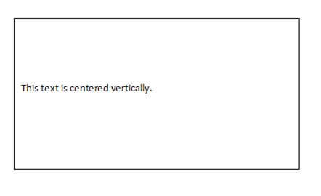
However, if this compatibility setting is turned on:
<w:compat>
<w:doNotVertAlignInTxbx />
</w:compat>
Then the text shall always be top aligned, regardless of the -text-anchor property, resulting in the following output:
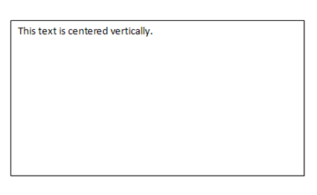
end example]
Parent Elements
compat (§2.15.3.9)

Attributes | Description
val (On/Off Value) | Specifies a binary value for the property defined by the parent XML element.  A value of on, 1, or true specifies that the property shall be explicitly applied. This is the default value for this attribute, and is implied when the parent element is present, but this attribute is omitted.  A value of off, 0, or false specifies that the property shall be explicitly turned off.  [Example: For example, consider the following on/off property:  <w:… w:val="off"/>  The val attribute explicitly declares that the property is turned off. end example]  The possible values for this attribute are defined by the ST_OnOff simple type (§2.18.67).
The following XML Schema fragment defines the contents of this element:
<complexType name="CT_OnOff">
<attribute name="val" type="ST_OnOff"/>
</complexType>

