doNotUseIndentAsNumberingTabStop (Ignore Hanging Indent When Creating Tab Stop After Numbering)
This element specifies whether applications shall use the custom tab stop generated by the hanging indent (if any) when advancing the text after the numbering for a numbered paragraph.
Typically, a hanging indent on a paragraph creates a virtual custom tab stop at that location, and therefore a tab added after the numbering on a numbered paragraph by the suff element (§2.9.30) shall advance to that tab stop, so that the text of the numbered paragraph begins at that location. This element, when present with a val attribute value of true (or equivalent), specifies that a tab stop added as the suffix to the numbering of a numbered paragraph shall ignore that virtual custom tab stop and shall instead advance to the next real tab stop (custom or automatic) on the current line.
[Example: Consider a WordprocessingML document with numbering, whose first level of numbering specifies a tab stop suffix, a hanging indent at 1", and a custom tab stop at 2":
<w:abstractNum w:numId="0">
…
<w:lvl w:ilvl="0">
<w:suff w:val="tab" />
<w:pPr>
<w:ind w:left="1440" w:hanging="1440" />
<w:tabs>
<w:tab w:val="2880" />
</w:tabs>
</w:pPr>
</w:lvl>
</w:abstractNum>
The default presentation of this document results in the tab stop generated by the numbering advancing to the virtual tab stop generated by the hanging indent at 1", as follows:
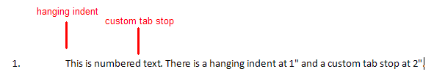
However, if this compatibility setting is turned on:
<w:compat>
<w:dontUseIndentAsNumberingTabStop />
</w:compat>
Then that tab suffix ignores the virtual tab stop of the hanging indent, so it must advance to the next custom tab stop on the line (at 2"), resulting in the following output:
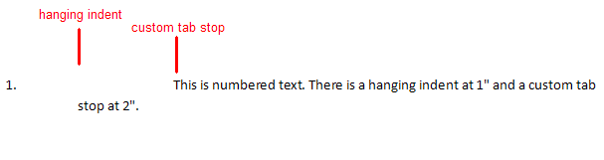
end example]
Parent Elements
compat (§2.15.3.9)

Attributes | Description
val (On/Off Value) | Specifies a binary value for the property defined by the parent XML element.  A value of on, 1, or true specifies that the property shall be explicitly applied. This is the default value for this attribute, and is implied when the parent element is present, but this attribute is omitted.  A value of off, 0, or false specifies that the property shall be explicitly turned off.  [Example: For example, consider the following on/off property:  <w:… w:val="off"/>  The val attribute explicitly declares that the property is turned off. end example]  The possible values for this attribute are defined by the ST_OnOff simple type (§2.18.67).
The following XML Schema fragment defines the contents of this element:
<complexType name="CT_OnOff">
<attribute name="val" type="ST_OnOff"/>
</complexType>

