doNotUseEastAsianBreakRules (Do Not Compress Compressible Characters When Using Document Grid)
This element specifies whether applications should compress characters with identical compression rules when the document grid has been defined using the docGrid element (§2.6.5). Compression rules refer to the additional bearing on the left and/or right side of a typical character, which can be compressed as needed without modifying the actual width of the character (its breadth).
Typically, punctuation characters with an identical set of compression rules are compressed when the contents of a document are displayed. This element, when present with a val attribute value of true (or equivalent), specifies that if a document grid is defined for the current section, compression shall never be performed on any character - all compressible characters shall be individually snapped to the document grid.
[Example: Consider a WordprocessingML document with a document grid set to allow 10 characters per line:
<w:sectPr>
<w:docGrid w:type="snapToChars" w:charSpace="146636" … />
</w:sectPr>
The default presentation would allow characters with identical compression rules to compress and utilize a single slot on the document grid (notice that the four parenthesis on the first line are combined since they can be compressed identically, while the two parenthesis with different compression on line two are not):
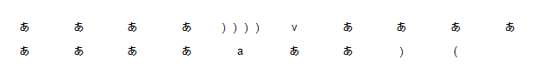
However, if this compatibility setting is turned on:
<w:compat>
<w:useEastAsianBreakRules />
</w:compat>
Then no character with compression is compressed and instead are snapped to the grid individually, resulting in the following output:
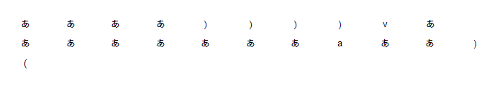
end example]
Parent Elements
compat (§2.15.3.9)

Attributes | Description
val (On/Off Value) | Specifies a binary value for the property defined by the parent XML element.  A value of on, 1, or true specifies that the property shall be explicitly applied. This is the default value for this attribute, and is implied when the parent element is present, but this attribute is omitted.  A value of off, 0, or false specifies that the property shall be explicitly turned off.  [Example: For example, consider the following on/off property:  <w:… w:val="off"/>  The val attribute explicitly declares that the property is turned off. end example]  The possible values for this attribute are defined by the ST_OnOff simple type (§2.18.67).
The following XML Schema fragment defines the contents of this element:
<complexType name="CT_OnOff">
<attribute name="val" type="ST_OnOff"/>
</complexType>

