bordersDoNotSurroundHeader (Page Border Excludes Header)
This element specifies that a given WordprocessingML document’s page border specified using the pgBorders element (§2.6.10) should not surround contents of the header.
If this element is omitted, then the page border shall not exclude the header on the page. As well, this element shall be ignored if the pgBorders element has a offsetFrom attribute which is not equal to text.
[Note: If the pgBorders element has a offsetFrom attribute equal to page, the bordersDontSurroundHeader element shall be ignored as specifying the pgBorders element with a offsetFrom attribute equal to page is to specify that the positioning of borders within the document shall be calculated relative to the edge of the page and therefore irrespective of document content in the header. end note]
[Example: Consider the following page in a WordprocessingML document:
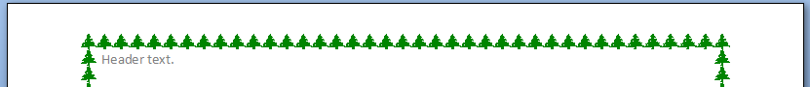
If this WordprocessingML document is modified to leverage the behavior enabled by this element, this setting would be specified using the following WordprocessingML fragment in the document settings:
<w:bordersDontSurroundHeader w:val="true"/>
The bordersDontSurroundHeader element's val attribute is equal to true specifying that the page border shall not surround the text extents of the header, as follows:
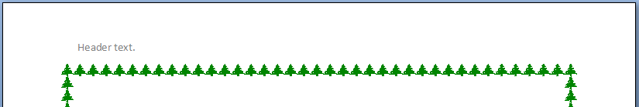
end example]
Parent Elements
settings (§2.15.1.78)

Attributes | Description
val (On/Off Value) | Specifies a binary value for the property defined by the parent XML element.  A value of on, 1, or true specifies that the property shall be explicitly applied. This is the default value for this attribute, and is implied when the parent element is present, but this attribute is omitted.  A value of off, 0, or false specifies that the property shall be explicitly turned off.  [Example: For example, consider the following on/off property:  <w:… w:val="off"/>  The val attribute explicitly declares that the property is turned off. end example]  The possible values for this attribute are defined by the ST_OnOff simple type (§2.18.67).
The following XML Schema fragment defines the contents of this element:
<complexType name="CT_OnOff">
<attribute name="val" type="ST_OnOff"/>
</complexType>

