allowSpaceOfSameStyleInTable (Allow Contextual Spacing of Paragraphs in Tables)
This element specifies whether the suppression of additional space (contextual spacing) defined using the contextualSpacing element (§2.3.1.9) shall be applied to paragraphs contained within tables.
Typically, the rules for the removal of additional paragraph spacing via the contextualSpacing element are applied to all paragraphs in a WordprocessingML document. This element, when present with a val attribute value of true (or equivalent), specifies that this setting shall always be ignored for paragraphs in table cells (and additional spacing shall be allowed).
[Example: Consider a WordprocessingML document with a default paragraph style with additional spacing after and contextual spacing set, as follows:
<w:style w:name="Normal" w:default="1">
…
<w:pPr>
<w:spacing w:after="200" />
<w:contextualSpacing />
</w:pPr>
</w:style>
The default presentation would have the spacing suppressed between all paragraphs, since they are all of the default paragraph style defined above (contextual spacing applies):
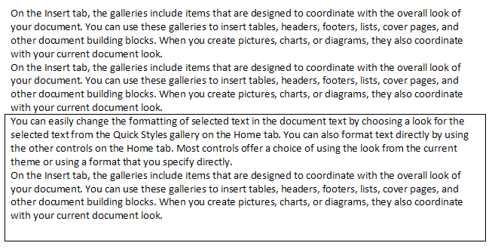
However, if this compatibility setting is turned on:
<w:compat>
<w:allowSpaceOfSameStyleInTable />
</w:compat>
Then the paragraphs in the table will never have their spacing suppressed, resulting in the following output:
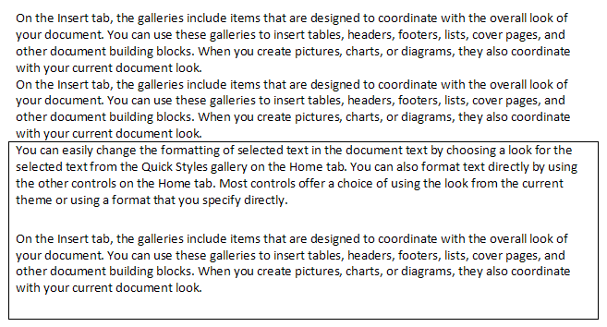
end example]
Parent Elements
compat (§2.15.3.9)

Attributes | Description
val (On/Off Value) | Specifies a binary value for the property defined by the parent XML element.  A value of on, 1, or true specifies that the property shall be explicitly applied. This is the default value for this attribute, and is implied when the parent element is present, but this attribute is omitted.  A value of off, 0, or false specifies that the property shall be explicitly turned off.  [Example: For example, consider the following on/off property:  <w:… w:val="off"/>  The val attribute explicitly declares that the property is turned off. end example]  The possible values for this attribute are defined by the ST_OnOff simple type (§2.18.67).
The following XML Schema fragment defines the contents of this element:
<complexType name="CT_OnOff">
<attribute name="val" type="ST_OnOff"/>
</complexType>

