adjustLineHeightInTable (Add Document Grid Line Pitch To Lines in Table Cells)
This element specifies whether a document grid defined using the docGrid element (§2.6.5) that specifies a line grid (manually adding additional pitch to each line in the section) shall also be applied to lines within table cells in this section.
Typically, when additional line pitch is added to all lines in a section via the document grid, it is not applied to text in tables. This element, when present with a val attribute value of true (or equivalent), specifies that additional line pitch shall be added to lines in table cells.
[Example: Consider a WordprocessingML document with a single section, whose document grid is defined such that 25.9 points of additional line pitch are added to each line in the section, as follows:
<w:docGrid w:type="lines" w:linePitch="518"/>
If text was entered into this section, the default behavior would have line pitch only added to lines which are not in a table cell:
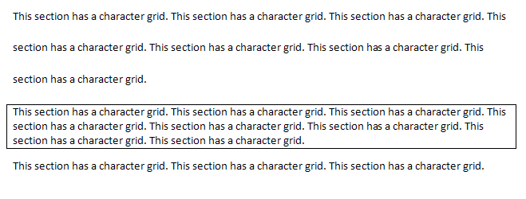
However, if this compatibility setting is turned on:
<w:compat>
<w:adjustLineHeightInTable />
</w:compat>
Then all lines in this document would have the line pitch from the document grid added to them, resulting in the following output:
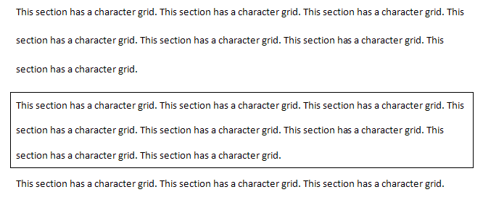
end example]
Parent Elements
compat (§2.15.3.9)

Attributes | Description
val (On/Off Value) | Specifies a binary value for the property defined by the parent XML element.  A value of on, 1, or true specifies that the property shall be explicitly applied. This is the default value for this attribute, and is implied when the parent element is present, but this attribute is omitted.  A value of off, 0, or false specifies that the property shall be explicitly turned off.  [Example: For example, consider the following on/off property:  <w:… w:val="off"/>  The val attribute explicitly declares that the property is turned off. end example]  The possible values for this attribute are defined by the ST_OnOff simple type (§2.18.67).
The following XML Schema fragment defines the contents of this element:
<complexType name="CT_OnOff">
<attribute name="val" type="ST_OnOff"/>
</complexType>

