ST_TblOverlap (Table Overlap Setting)
This simple type contains the possible settings for a floating table which shall be used to determine if the table can overlap with other floating tables when displayed in the document.
[Example: Consider two floating tables in a WordprocessingML document which overlap when displayed, as follows:
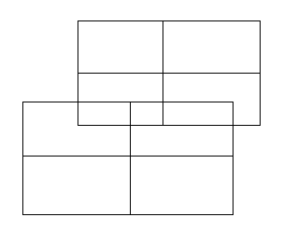
If either of these tables specifies that it shall not allow overlapping, using the following WordprocessingML:
<w:tblPr>
<w:tblOverlap w:val="never"/>
</w:tblPr>
The resulting tables shall not overlap, and must be adjusted at display time to prevent any overlapping, for example:
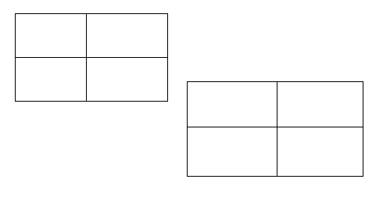
The value of never specifies that the specified table cannot overlap with other floating tables in the document. end example]
This simple type's contents are a restriction of the XML Schema string datatype.
The following are possible enumeration values for this type:
Enumeration Value | Description
never (Floating Table Cannot Overlap) | Specifies that the parent table, if floating, shall never be displayed in a state where it would be overlapping another floating table in the document.  If two floating tables intersect and this option is set on either of them, then one or both tables shall be adjusted as needed to ensure that the table whose value is never is not overlapped when displayed.
overlap (Floating Table Can Overlap) | Specifies that the parent table, if floating, may be displayed in a state where it would be overlapping another floating table in the document.

Referenced By
tblOverlap@val (§2.4.53)
The following XML Schema fragment defines the contents of this simple type:
<simpleType name="ST_TblOverlap">
<restriction base="xsd:string">
<enumeration value="never"/>
<enumeration value="overlap"/>
</restriction>
</simpleType>

