ST_FrameLayout (Frameset Layout Order)
This simple type specifies the possible order in which the frames (and nested framesets) in a frameset may be displayed. When a frameset is created, it can only contain frames which are stacked in one direction:
- Vertically (one on top of another)
- Horizontally (one next to another)
[Example: Consider a WordprocessingML document which serves as the frameset container for a frameset consisting of the following three frames:
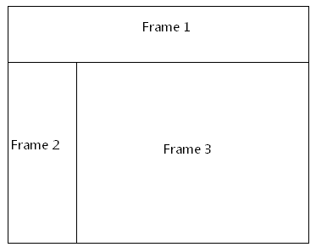
The frameset properties for this document are specified by the following WordprocessingML within the web page settings:
<w:frameset>
<w:frameLayout w:val="rows" />
<w:frame>
…
</w:frame>
<w:frameset>
<w:frameLayout w:val="cols" />
<w:frame>
…
</w:frame>
<w:frame>
…
</w:frame>
</w:frameset>
</w:frameset>
The frameLayout element specifies that the outer frameset is consists of the single frame and the child frameset stacked vertically, and an inner nested frameset consisting of two frames stacked horizontally. end example]
This simple type's contents are a restriction of the XML Schema string datatype.
The following are possible enumeration values for this type:
Enumeration Value | Description
cols (Stack Frames Horizontally) | Specifies that the frames in the frameset shall be stacked horizontally next to each other in left to right order.
none (Do Not Stack Frames) | Specifies that no frames shall be shown in the frameset.
rows (Stack Frames Vertically) | Specifies that the frames in the frameset shall be stacked vertically next to each other in top to bottom order.

Referenced By
frameLayout@val (§2.15.2.17)
The following XML Schema fragment defines the contents of this simple type:
<simpleType name="ST_FrameLayout">
<restriction base="xsd:string">
<enumeration value="rows"/>
<enumeration value="cols"/>
<enumeration value="none"/>
</restriction>
</simpleType>

