ST_CaptionPos (Automatic Caption Positioning Values)
This simple type specifies the possible values may be used for the position of an automatically inserted caption on an object within this document. These values specify the position a given caption shall be take relative to the object it is used to label.
[Example: Consider a WordprocessingML document which should have all automatically inserted captions placed below the objects they are captioning, for example:
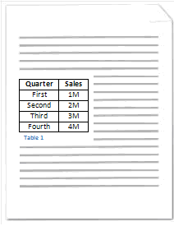
This requirement is specified using the following WordprocessingML in the document settings:
<w:captions>
<w:caption w:name="Table" w:pos="below" w:numFmt="decimal" />
</w:captions>
The pos attribute has a value of below, specifying that the caption shall be placed below the newly inserted objects. end example]
This simple type's contents are a restriction of the XML Schema string datatype.
The following are possible enumeration values for this type:
Enumeration Value | Description
above (Position Caption Above Object) | Specifies that an automatically inserted caption shall be positioned above the object that it is used to label.
below (Position Caption Below Object) | Specifies that an automatically inserted caption shall be positioned below the object that it is used to label.
left (Position Caption Left Of Object) | Specifies that an automatically inserted caption shall be positioned to the left of the object that it is used to label (the position where text typed immediately before the object would appear).
right (Position Caption Right Of Object) | Specifies that an automatically inserted caption shall be positioned to the right of the object that it is used to label (the position where text typed immediately after the object would appear).

Referenced By
caption@pos (§2.15.1.16)
The following XML Schema fragment defines the contents of this simple type:
<simpleType name="ST_CaptionPos">
<restriction base="xsd:string">
<enumeration value="above"/>
<enumeration value="below"/>
<enumeration value="left"/>
<enumeration value="right"/>
</restriction>
</simpleType>

