tableStyleElement (Table Style)
This element specifies formatting for one area of a table or PivotTable. Together the sequence of these elements makes up one entire Table style or PivotTable style definition.
The order in which table style element formatting is applied is as follows:
Table Style Element Order
- Whole Table
- First Column Stripe
- Second Column Stripe
- First Row Stripe
- Second Row Stripe
- Last Column
- First Column
- Header Row
- Total Row
- First Header Cell
- Last Header Cell
- First Total Cell
- Last Total Cell
For instance, row stripe formatting 'wins' over column stripe formatting, and both 'win' over whole table formatting.

PivotTable Style Element Order
- Whole Table
- Page Field Labels
- Page Field Values
- First Column Stripe
- Second Column Stripe
- First Row Stripe
- Second Row Stripe
- First Column
- Header Row
- First Header Cell
- Subtotal Column 1
- Subtotal Column 2
- Subtotal Column 3
- Blank Row
- Subtotal Row 1
- Subtotal Row 2
- Subtotal Row 3
- Column Subheading 1
- Column Subheading 2
- Column Subheading 3
- Row Subheading 1
- Row Subheading 2
- Row Subheading 3
- Grand Total Column
- Grand Total Row
Parent Elements
tableStyle (§3.8.40)

Attributes | Description
dxfId (Formatting Id) | Zero-based index to a dxf record in the dxfs collection, specifying differential formatting to use with this Table or PivotTable style element.  The possible values for this attribute are defined by the ST_DxfId simple type (§3.18.26).
size (Band Size) | Number of rows or columns in a single band of striping. Applies only when type is firstRowStripe, secondRowStripe, firstColumnStripe, or secondColumnStripe.  [Example:  In this example, the firstRowStripe size is set to 2, and the secondRowStripe size is set to 1:  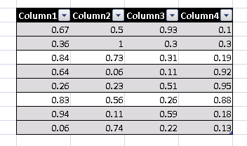  end example]  The possible values for this attribute are defined by the XML Schema unsignedInt datatype.
type (Table Style Type) | Identifies this table style element's type.  The possible values for this attribute are defined by the ST_TableStyleType simple type (§3.18.79).
The following XML Schema fragment defines the contents of this element:
<complexType name="CT_TableStyleElement">
<attribute name="type" type="ST_TableStyleType" use="required"/>
<attribute name="size" type="xsd:unsignedInt" use="optional" default="1"/>
<attribute name="dxfId" type="ST_DxfId" use="optional"/>
</complexType>

