raf (Revision AutoFormat)
This element represents a revision record of auto formatting change information for a table.
Parent Elements
revisions (§3.11.1.16)

Attributes | Description
applyAlignmentFormats (Apply Alignment Formats) | If true apply legacy table autoformat alignment properties.  The possible values for this attribute are defined by the XML Schema boolean datatype.
applyBorderFormats (Apply Border Formats) | If true apply legacy table autoformat border properties.  The possible values for this attribute are defined by the XML Schema boolean datatype.
applyFontFormats (Apply Font Formats) | If true apply legacy table autoformat font properties.  The possible values for this attribute are defined by the XML Schema boolean datatype.
applyNumberFormats (Apply Number Formats) | If true apply legacy table autoformat number format properties.  The possible values for this attribute are defined by the XML Schema boolean datatype.
applyPatternFormats (Apply Pattern Formats) | If true apply legacy table autoformat pattern properties.  The possible values for this attribute are defined by the XML Schema boolean datatype.
applyWidthHeightFormats (Apply Width / Height Formats) | If true apply legacy table autoformat width/height properties.  The possible values for this attribute are defined by the XML Schema boolean datatype.
autoFormatId (Auto Format Id) | Identifies which legacy table autoformat to apply.  Here are representations of the supported table autoformats:  autoFormatId Description  0 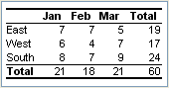  1 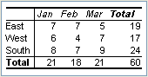  2 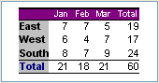  3 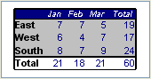  4 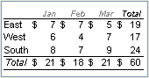  5 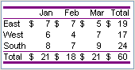  6 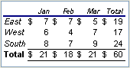  7 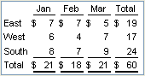  8 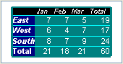  9 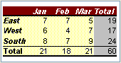  10 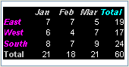  11 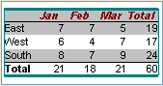  12 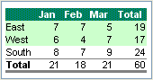  13 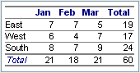  14 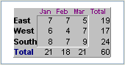  15 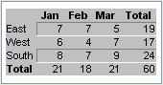  16 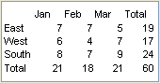  The possible values for this attribute are defined by the XML Schema unsignedInt datatype.
ref (Reference) | A-1 style reference to the location where the formatting was applied  The possible values for this attribute are defined by the ST_Ref simple type (§3.18.64).
sheetId (Sheet Id) | An integer representing the internal id of the sheet on which the revision occurred.  The possible values for this attribute are defined by the XML Schema unsignedInt datatype.
The following XML Schema fragment defines the contents of this element:
<complexType name="CT_RevisionAutoFormatting">
<attribute name="sheetId" type="xsd:unsignedInt" use="required"/>
<attributeGroup ref="AG_AutoFormat"/>
<attribute name="ref" type="ST_Ref" use="required"/>
</complexType>

