ST_TableStyleType (Table Style Type)
Enumeration of the different structured regions of a Table or PivotTable which can be formatted. Specifies which region is being formatted by this table style element.
Table Regions
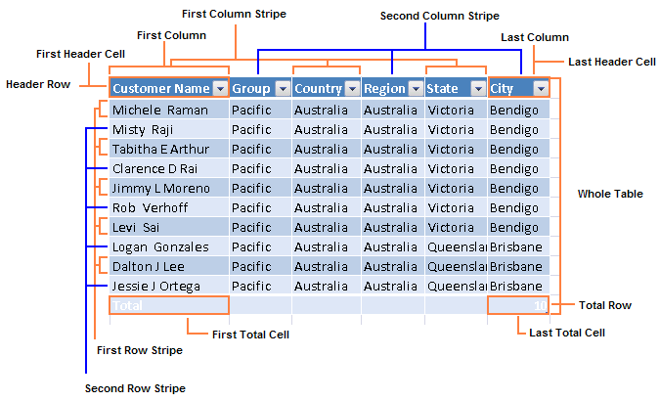
PivotTable Regions
Blank Row
Only applies when "Insert blank row after each item" is ON.
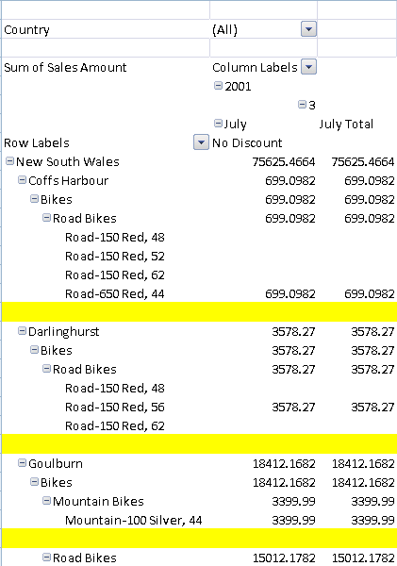
Whole Table
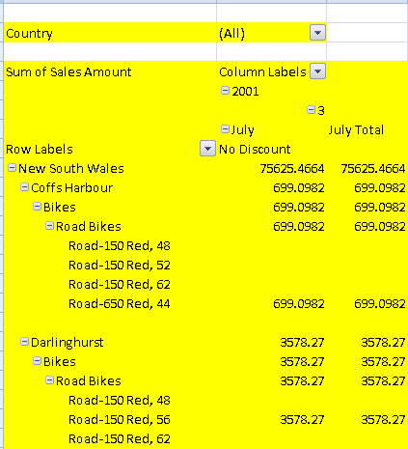
Page Field Labels
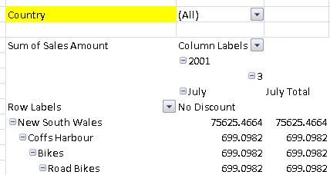
Page Field Values
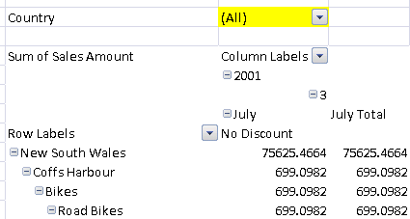
First Column Stripe
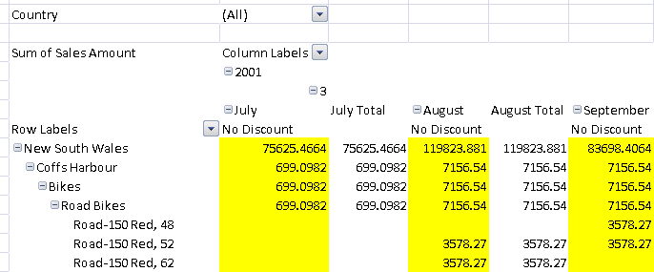
Second Column Stripe
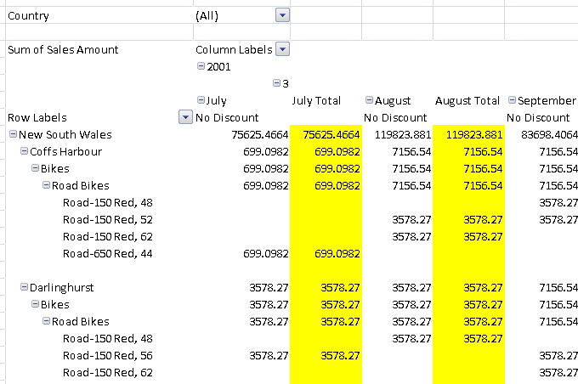
First Row Stripe
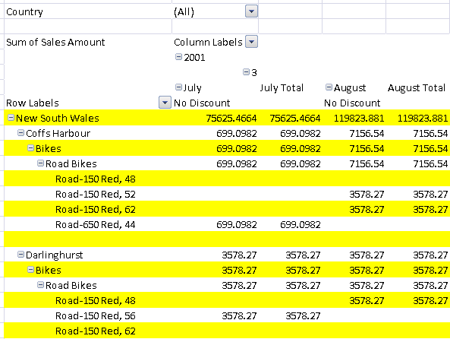
Second Row Stripe
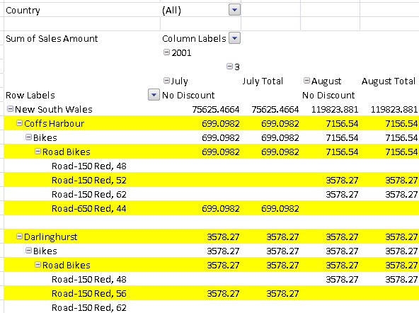
First Column
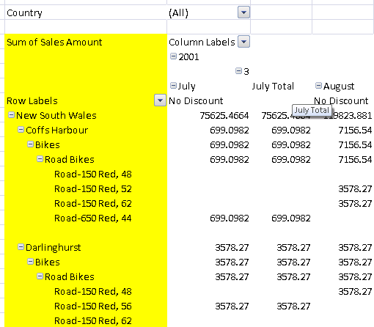
Header Row
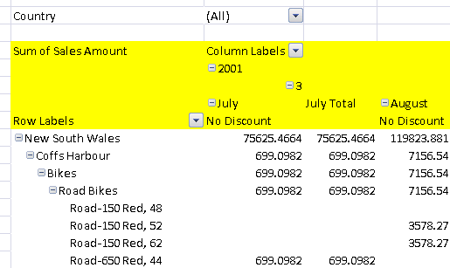
First Header Cell
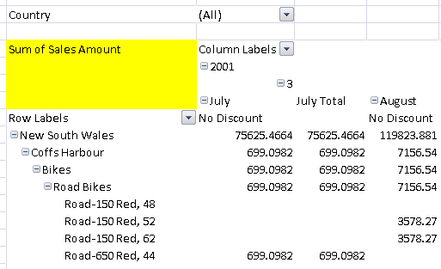
Subtotal Column 1
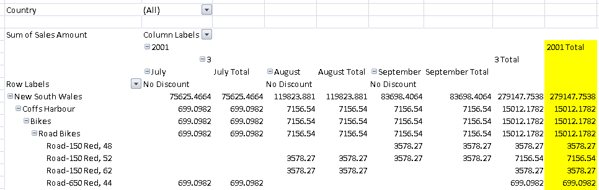
Subtotal Column 2
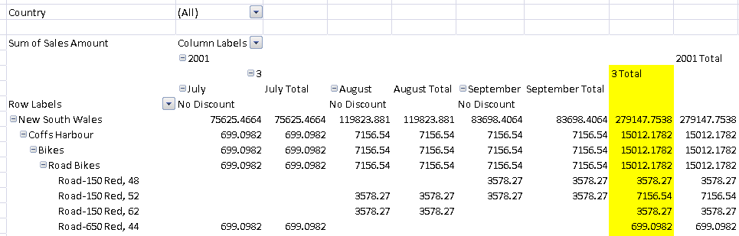
Subtotal Column 3
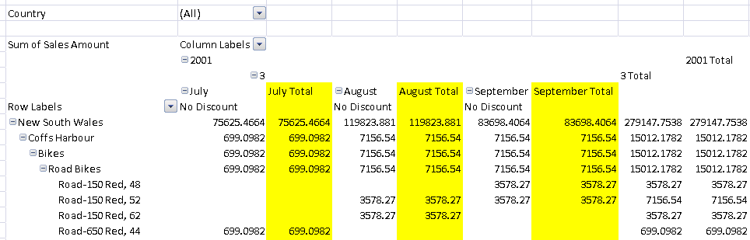
Subtotal Row 1
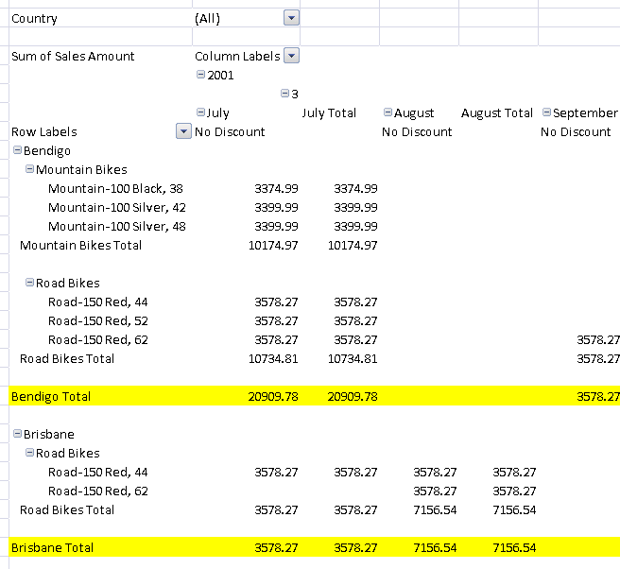
Subtotal Row 2
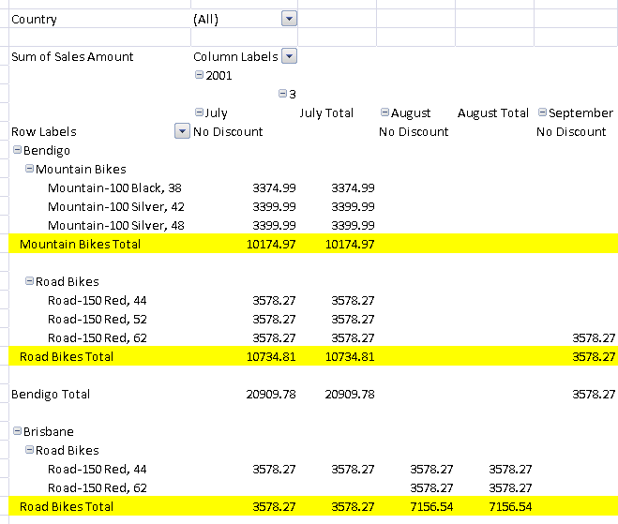Subtotal Row 3
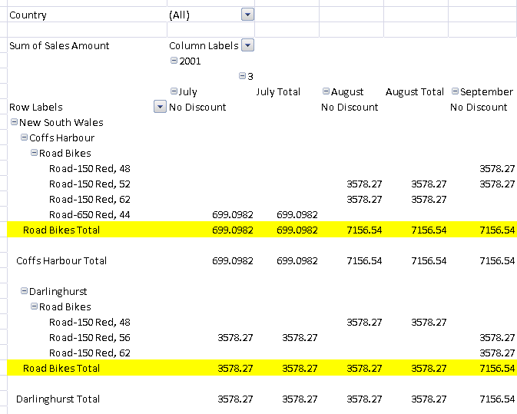
Column Subheading 1
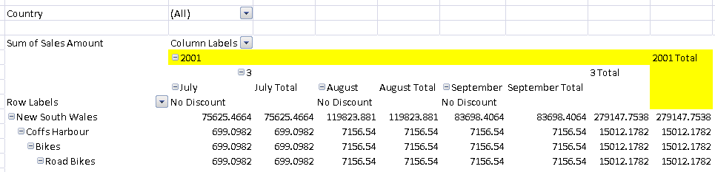
Column Subheading 2
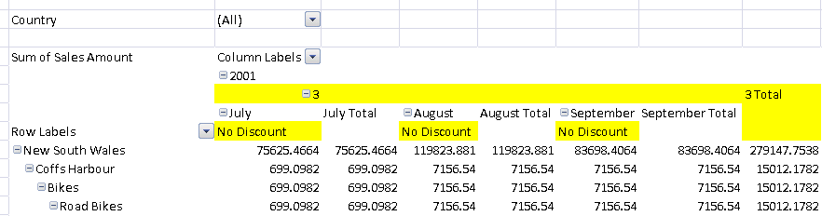
Column Subheading 3
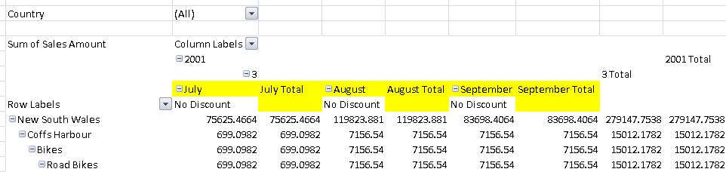
Row Subheading 1
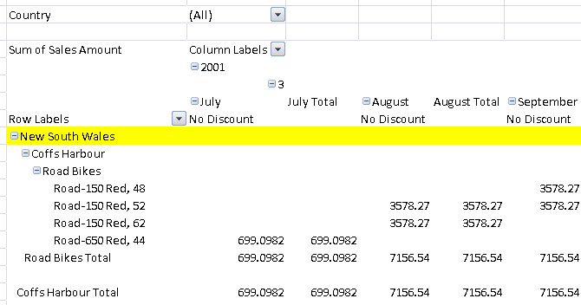
Row Subheading 2
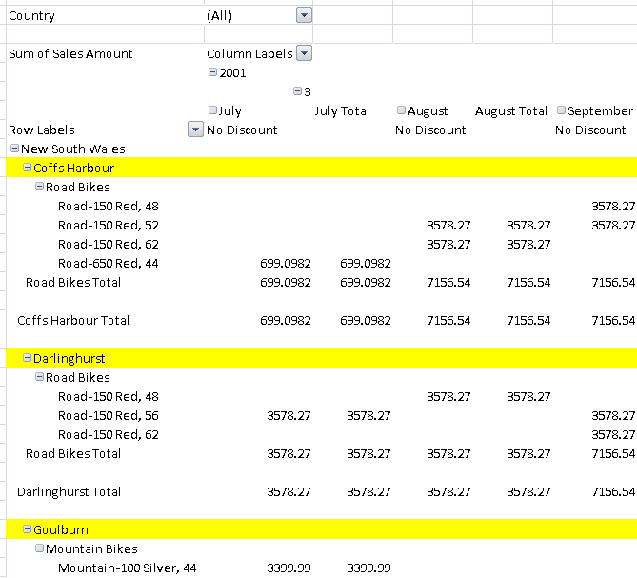
Row Subheading 3
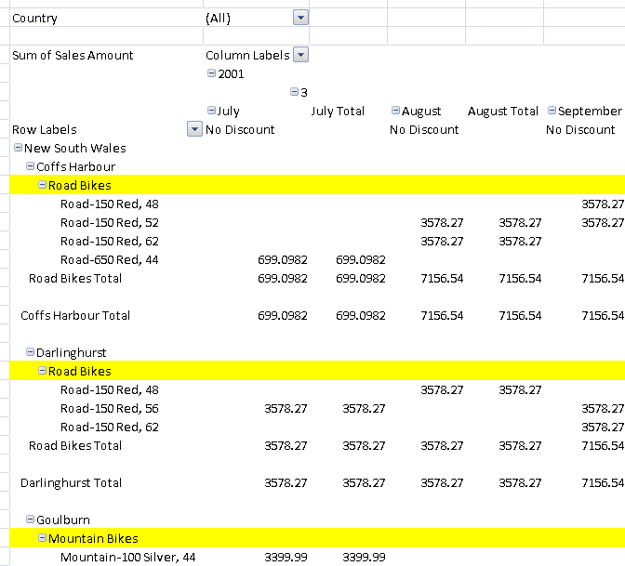Grand Total Column
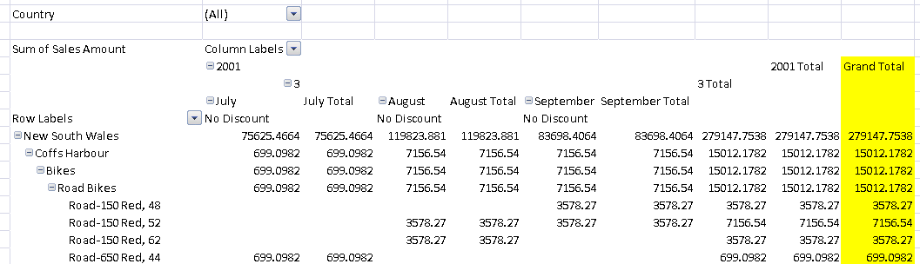
Grand Total Row
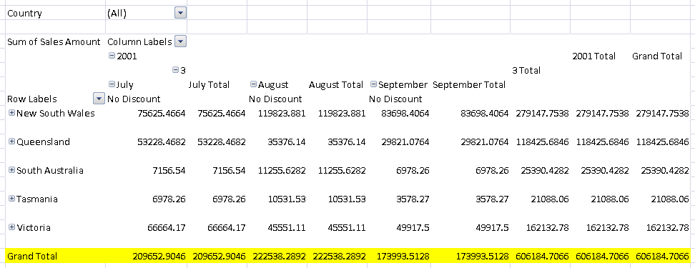

This simple type's contents are a restriction of the XML Schema string datatype.
The following are possible enumeration values for this type:
Enumeration Value | Description
blankRow (Blank Row Style) | Table style element that applies to PivotTable's blank rows.
firstColumn (First Column Style) | Table style element that applies to table's first column.
firstColumnStripe (First Column Stripe Style) | Table style element that applies to table's first column stripes.
firstColumnSubheading (First Column Subheading Style) | Table style element that applies to PivotTable's first column subheading.
firstHeaderCell (First Header Row Style) | Table style element that applies to table's first header row cell.
firstRowStripe (First Row Stripe Style) | Table style element that applies to table's first row stripes.
firstRowSubheading (First Row Subheading Style) | Table style element that applies to PivotTable's first row subheading.
firstSubtotalColumn (First Subtotal Column Style) | Table style element that applies to PivotTable's first subtotal column.
firstSubtotalRow (First Subtotal Row Style) | Table style element that applies to pivot table's first subtotal row.
firstTotalCell (First Total Row Style) | Table style element that applies to table's first total row cell.
headerRow (Header Row Style) | Table style element that applies to table's header row.
lastColumn (Last Column Style) | Table style element that applies to table's last column.
lastHeaderCell (Last Header Style) | Table style element that applies to table's last header row cell.
lastTotalCell (Last Total Row Style) | Table style element that applies to table's last total row cell.
pageFieldLabels (Page Field Labels Style) | Table style element that applies to pivot table's page field labels.
pageFieldValues (Page Field Values Style) | Table style element that applies to pivot table's page field values.
secondColumnStripe (Second Column Stipe Style) | Table style element that applies to table's second column stripes.
secondColumnSubheading (Second Column Subheading Style) | Table style element that applies to pivot table's second column subheading.
secondRowStripe (Second Row Stripe Style) | Table style element that applies to table's second row stripes.
secondRowSubheading (Second Row Subheading Style) | Table style element that applies to pivot table's second row subheading.
secondSubtotalColumn (Second Subtotal Column Style) | Table style element that applies to PivotTable's second subtotal column.
secondSubtotalRow (Second Subtotal Row Style) | Table style element that applies to PivotTable's second subtotal row.
thirdColumnSubheading (Third Column Subheading Style) | Table style element that applies to PivotTable's third column subheading.
thirdRowSubheading (Third Row Subheading Style) | Table style element that applies to PivotTable's third row subheading.
thirdSubtotalColumn (Third Subtotal Column Style) | Table style element that applies to pivot table's third subtotal column.
thirdSubtotalRow (Third Subtotal Row Style) | Table style element that applies to PivotTable's third subtotal row.
totalRow (Total Row Style) | Table style element that applies to table's total row.
wholeTable (Whole Table Style) | Table style element that applies to table's entire content.

Referenced By
tableStyleElement@type (§3.8.41)
The following XML Schema fragment defines the contents of this simple type:
<simpleType name="ST_TableStyleType">
<restriction base="xsd:string">
<enumeration value="wholeTable"/>
<enumeration value="headerRow"/>
<enumeration value="totalRow"/>
<enumeration value="firstColumn"/>
<enumeration value="lastColumn"/>
<enumeration value="firstRowStripe"/>
<enumeration value="secondRowStripe"/>
<enumeration value="firstColumnStripe"/>
<enumeration value="secondColumnStripe"/>
<enumeration value="firstHeaderCell"/>
<enumeration value="lastHeaderCell"/>
<enumeration value="firstTotalCell"/>
<enumeration value="lastTotalCell"/>
<enumeration value="firstSubtotalColumn"/>
<enumeration value="secondSubtotalColumn"/>
<enumeration value="thirdSubtotalColumn"/>
<enumeration value="firstSubtotalRow"/>
<enumeration value="secondSubtotalRow"/>
<enumeration value="thirdSubtotalRow"/>
<enumeration value="blankRow"/>
<enumeration value="firstColumnSubheading"/>
<enumeration value="secondColumnSubheading"/>
<enumeration value="thirdColumnSubheading"/>
<enumeration value="firstRowSubheading"/>
<enumeration value="secondRowSubheading"/>
<enumeration value="thirdRowSubheading"/>
<enumeration value="pageFieldLabels"/>
<enumeration value="pageFieldValues"/>
</restriction>
</simpleType>

