ODDLYIELD
Syntax:
ODDLYIELD ( settlement , maturity , last-interest , rate , pr , redemption ,
frequency [ , [ basis ] ] )
Description: Computes the yield of a security that has an odd (short or long) last period.
Mathematical Formula:
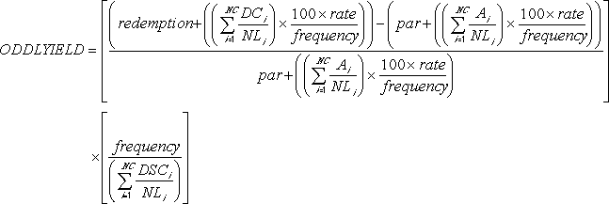
where:
Ai = number of accrued days for the ith, or last, quasi-coupon period within odd period counting forward from last interest date before redemption.
DCi = number of days counted in the ith, or last, quasi-coupon period as delimited by the length of the actual coupon period.
NC = number of quasi-coupon periods that fit in odd period; if this number contains a fraction it will be raised to the next whole number.
NLi = normal length in days of the ith, or last, quasi-coupon period within odd coupon period.
Arguments:
Name | Type | Description
settlement | number | The security's settlement date.
maturity | number | The security's maturity date.
last-interest | number | The security's last coupon date.
rate | number | The security's interest rate.
pr | number | The security's price.
redemption | number | The security's redemption value per $100 face value.
frequency | number | the number of coupon payments per year. (For annual payments, frequency is 1; for semiannual payments, frequency is 2; for quarterly payments, frequency is 4.)
basis | number | The truncated integer type of day count basis to use, as follows:  Value Day Count Basis  0 or omitted US (NASD) 30/360  1 Actual/actual  2 Actual/360  3 Actual/365  4 European 30/360

Time information in the date arguments is ignored.
Return Type and Value: number – The yield of a security that has an odd (short or long) last period.
However, if
- settlement, maturity, or last-interest is out of range for the current date base value, #NUM! is returned.
- The following is not true: maturity is later than settlement, which is later than last-interest, so #NUM! is returned.
- rate or pr < 0, #NUM! is returned.
- frequency is any number other than 1, 2, or 4, #NUM! is returned.
- basis < 0 or basis > 4, #NUM! is returned.
[Example:
ODDLYIELD(DATE(2008,11,11),DATE(2021,3,1),DATE(2008,10,15),
0.0575,84.5,100,2,0) results in 4.5192%
end example]

