ODDFPRICE
Syntax:
ODDFPRICE ( settlement , maturity , issue , first-coupon , rate , yld , redemption ,
frequency [ , [ basis ] ] )
Description: Computes the price per $100 face value of a security having an odd (short or long) first period.
Mathematical Formula:
Odd short first coupon:
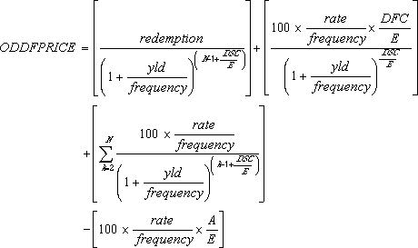
where:
A = number of days from the beginning of the coupon period to the settlement date (accrued days).
DSC = number of days from the settlement to the next coupon date.
DFC = number of days from the beginning of the odd first coupon to the first coupon date.
E = number of days in the coupon period.
N = number of coupons payable between the settlement date and the redemption date. (If this number contains a fraction, it is raised to the next whole number.)
Odd long first coupon:
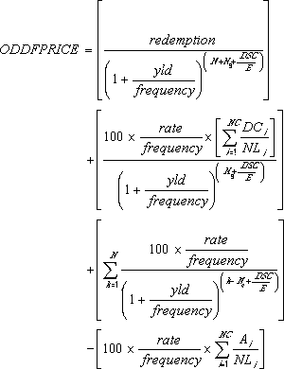
where:
Ai = number of days from the beginning of the ith, or last, quasi-coupon period within odd period.
DCi = number of days from dated date (or issue date) to first quasi-coupon (i = 1) or number of days in quasi-coupon (i = 2,..., i = NC).
DSC = number of days from settlement to next coupon date.
E = number of days in coupon period.
N = number of coupons payable between the first real coupon date and redemption date. (If this number contains a fraction, it is raised to the next whole number.)
NC = number of quasi-coupon periods that fit in odd period. (If this number contains a fraction, it is raised to the next whole number.)
NLi = normal length in days of the full ith, or last, quasi-coupon period within odd period.
Nq = number of whole quasi-coupon periods between settlement date and first coupon.
Arguments:
Name | Type | Description
settlement | number | The security's settlement date.
maturity | number | The security's maturity date.
issue | number | The security's issue date.
first-coupon | number | The security's first coupon date.
rate | number | The security's interest rate.
yld | number | The security's annual yield.
redemption | number | The security's redemption value per $100 face value.
frequency | number | the number of coupon payments per year. (For annual payments, frequency is 1; for semiannual payments, frequency is 2; for quarterly payments, frequency is 4.)
basis | number | The truncated integer type of day count basis to use, as follows:  Value Day Count Basis  0 or omitted US (NASD) 30/360  1 Actual/actual  2 Actual/360  3 Actual/365  4 European 30/360

Time information in the date arguments is ignored.
Return Type and Value: number – The price per $100 face value of a security having an odd (short or long) first period.
However, if
- settlement, maturity, issue, or first-coupon is out of range for the current date base value, #NUM! is returned.
- The following is not true: maturity is later than first-coupon, which is later than settlement, which is later than issue, so #NUM! is returned.
- rate or yld < 0, #NUM! is returned.
- frequency is any number other than 1, 2, or 4, #NUM! is returned.
- basis < 0 or basis > 4, #NUM! is returned.
[Example:
ODDFPRICE(DATE(2008,11,11),DATE(2021,3,1),DATE(2008,10,15),DATE(2009,3,1),
0.0785,0.0625,100,2,1) results in 113.5977
end example]

