brkBin (Break on Binary Operators)
This element specifies how binary operators are treated when they coincide with a line break. If this element is omitted, the line break occurs before the binary operator. That is, the binary operator is the first element on the wrapped line. [Example: For example: 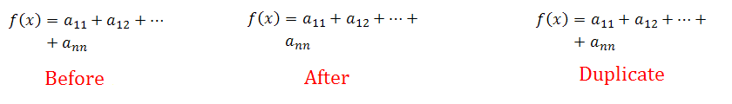
The XML below demonstrates brkBin in use under mathPr:
<m:mathPr>
<m:mathFont m:val="Cambria Math"/>
<m:brkBin m:val="before"/>
<m:brkBinSub m:val="--"/>
<m:smallFrac m:val="off"/>
<m:dispDef/>
<m:lMargin m:val="0"/>
<m:rMargin m:val="0"/>
<m:defJc m:val="centerGroup"/>
<m:wrapIndent m:val="1440"/>
<m:intLim m:val="subSup"/>
<m:naryLim m:val="undOvr"/>
</m:mathPr>
end example]
Parent Elements
mathPr (§7.1.2.62)

Attributes | Description
val (Value) | Specifies where to break on binary operators. Possible values are before, after, and repeat.  The possible values for this attribute are defined by the ST_BreakBin simple type (§7.1.3.1).
The following XML Schema fragment defines the contents of this element:
<complexType name="CT_BreakBin">
<attribute name="val" type="ST_BreakBin"/>
</complexType>

