sldSyncPr (Slide Synchronization Properties)
This element specifies the properties associated with the slide synchronization specified for the current slide.
Parent Elements
Root element of PresentationML Slide Synchronization Data part

Child Elements | Subclause
extLst (Extension List) | §4.2.5

Attributes | Description
clientInsertedTime (Client Slide Insertion date/time) | The date and time that the server-based slide was inserted into the client presentation. This field is used purely for informative purposes so that the user may know when the slide was inserted.  The date/time is stored in ISO 8061 format.  [Example: Notice the use of clientInsertedTime in this UI to provide users information on when the slide was inserted from the slide library.  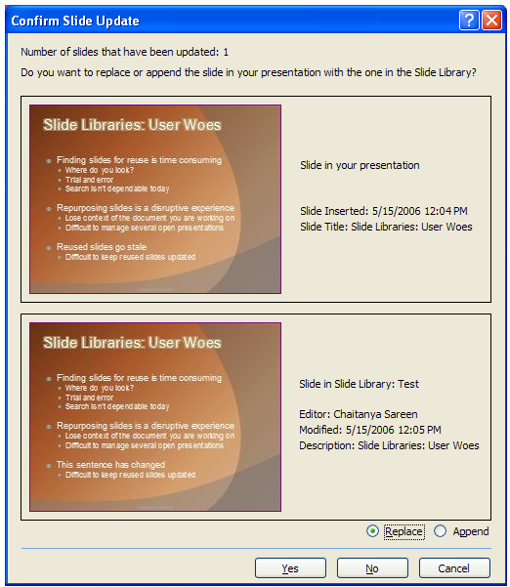  End Example]  The possible values for this attribute are defined by the XML Schema dateTime datatype.
serverSldId (Server's Slide File ID) | Identifier of the slide file on the server. This ID is unrelated to the Slide's ID, and is a unique identifier for the slide in the slide library.  The possible values for this attribute are defined by the XML Schema string datatype.
serverSldModifiedTime (Server's Slide File's modification date/time) | The last modification date and time for the slide file that is located on the server. This date, when compared with the last modification date and time on the server, determines whether an update of this slide is necessary.  The date and time are stored in ISO 8061 format.  The possible values for this attribute are defined by the XML Schema dateTime datatype.
The following XML Schema fragment defines the contents of this element:
<complexType name="CT_SlideSyncProperties">
<sequence>
<element name="extLst" type="CT_ExtensionList" minOccurs="0" maxOccurs="1"/>
</sequence>
<attribute name="serverSldId" type="xsd:string" use="required"/>
<attribute name="serverSldModifiedTime" type="xsd:dateTime" use="required"/>
<attribute name="clientInsertedTime" type="xsd:dateTime" use="required"/>
</complexType>

