excl (Exclusive)
This element describes the Exclusive time node. This time node is used to pause all other timelines when it is activated. Conceptually it can be though of as follows:
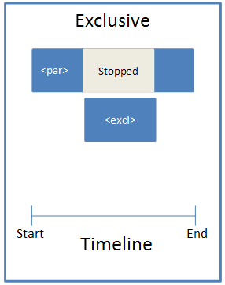
Parent Elements
childTnLst (§4.6.25); subTnLst (§4.6.78); tnLst (§4.6.87)

Child Elements | Subclause
cTn (Common Time Node Properties) | §4.6.33
The following XML Schema fragment defines the contents of this element:
<complexType name="CT_TLTimeNodeExclusive">
<sequence>
<element name="cTn" type="CT_TLCommonTimeNodeData" minOccurs="1" maxOccurs="1"/>
</sequence>
</complexType>

