bldLst (Build List)
This element specifies the list of graphic elements to build. This refers to how the different sub-shapes or sub-components of a object are displayed. The different objects that can have build properties are text, diagrams, and charts.
[Example: Consider animating a pie chart but based on category as shown below:
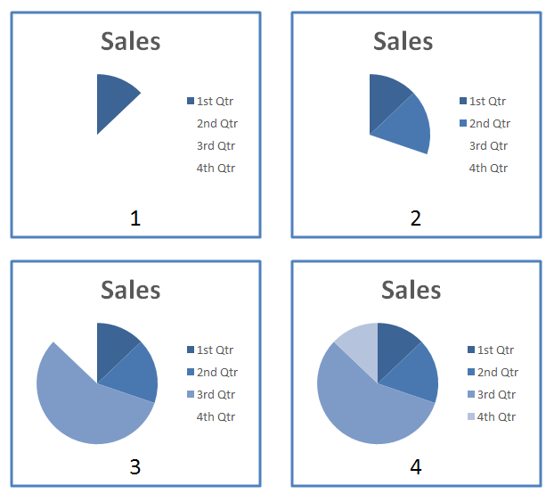
The <bldList> element should be used as follows:
<p:bldLst>
<p:bldGraphic spid="1" grpId="0">
<p:bldSub>
<a:bldChart bld="category"/>
</p:bldSub>
</p:bldGraphic>
</p:bldLst>
End example]
Parent Elements
timing (§4.4.1.44)

Child Elements | Subclause
bldDgm (Build Diagram) | §4.6.12
bldGraphic (Build Graphics) | §4.6.13
bldOleChart (Build Embedded Chart) | §4.6.15
bldP (Build Paragraph) | §4.6.16
The following XML Schema fragment defines the contents of this element:
<complexType name="CT_BuildList">
<choice minOccurs="1" maxOccurs="unbounded">
<element name="bldP" type="CT_TLBuildParagraph"/>
<element name="bldDgm" type="CT_TLBuildDiagram"/>
<element name="bldOleChart" type="CT_TLOleBuildChart"/>
<element name="bldGraphic" type="CT_TLGraphicalObjectBuild"/>
</choice>
</complexType>

