up (Up Vector)
This element defines a vector representing up. To be more precise, this attribute defines a vector representing up in relation to the face of the backdrop plane.
[Example: Consider the following image as an example of what an up vector is in relation to the backdrop plane:
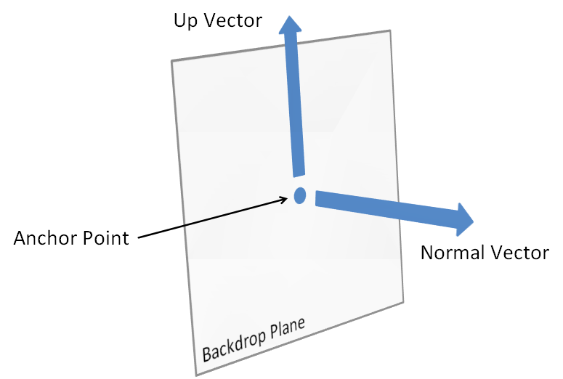
end example]
Parent Elements
backdrop (§5.1.7.2)

Attributes | Description
dx (Distance along X-axis in 3D) | Distance along X-axis in 3D  The possible values for this attribute are defined by the ST_Coordinate simple type (§5.1.12.16).
dy (Distance along Y-axis in 3D) | Distance along Y-axis in 3D  The possible values for this attribute are defined by the ST_Coordinate simple type (§5.1.12.16).
dz (Distance along Z-axis in 3D) | Distance along Z-axis in 3D  The possible values for this attribute are defined by the ST_Coordinate simple type (§5.1.12.16).
The following XML Schema fragment defines the contents of this element:
<complexType name="CT_Vector3D">
<attribute name="dx" type="ST_Coordinate" use="required"/>
<attribute name="dy" type="ST_Coordinate" use="required"/>
<attribute name="dz" type="ST_Coordinate" use="required"/>
</complexType>

