theme (Theme)
This element defines the root level complex type associated with a shared style sheet (or theme). This element holds all the different formatting options available to a document through a theme and defines the overall look and feel of the document when themed objects are used within the document.
[Example: Consider the following image as an example of different themes in use applied to a presentation:
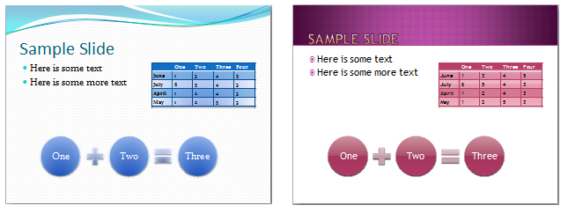
In this example, we see how a theme can affect font, colors, backgrounds, fills, and effects for different objects in a presentation. end example]
Parent Elements
Root element of DrawingML Theme part

Child Elements | Subclause
custClrLst (Custom Color List) | §5.1.8.3
extLst (Extension List) | §5.1.2.1.15
extraClrSchemeLst (Extra Color Scheme List) | §5.1.8.5
objectDefaults (Object Defaults) | §5.1.8.7
themeElements (Theme Elements) | §5.1.8.10

Attributes | Description
name (Name) | Specifies the name given to the theme.  The possible values for this attribute are defined by the XML Schema string datatype.
The following XML Schema fragment defines the contents of this element:
<complexType name="CT_OfficeStyleSheet">
<sequence>
<element name="themeElements" type="CT_BaseStyles" minOccurs="1" maxOccurs="1"/>
<element name="objectDefaults" type="CT_ObjectStyleDefaults" minOccurs="0" maxOccurs="1"/>
<element name="extraClrSchemeLst" type="CT_ColorSchemeList" minOccurs="0" maxOccurs="1"/>
<element name="custClrLst" type="CT_CustomColorList" minOccurs="0" maxOccurs="1"/>
<element name="extLst" type="CT_OfficeArtExtensionList" minOccurs="0" maxOccurs="1"/>
</sequence>
<attribute name="name" type="xsd:string" use="optional" default=""/>
</complexType>

