bevelB (Bottom Bevel)
This element holds the properties associated with defining a bevel on the bottom or back face of a shape.
[Example: Consider the following example of an sp3d containing a bottom bevel.
<a:sp3d>
<a:bevelB w="139700" h="127000" prst="coolSlant"/>
</a:sp3d>
In this example, we see a bottom bevel being defined with a preset bevel type along with a custom width and height. end example]
Parent Elements
sp3d (§5.1.7.12); sp3d (§5.9.5.6)

Attributes | Description
h (Height) | Specifies the height of the bevel, or how far above the shape it is applied.  [Example: Consider the following example bevel  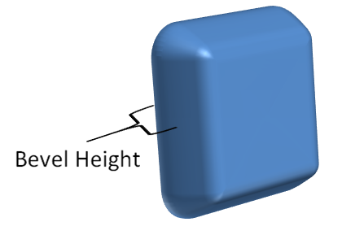  In this example, we see the height of an example bevel on a shape. end example]  The possible values for this attribute are defined by the ST_PositiveCoordinate simple type (§5.1.12.42).
prst (Preset Bevel) | Specifies the preset bevel type which defines the look of the bevel.  The possible values for this attribute are defined by the ST_BevelPresetType simple type (§5.1.12.9).
w (Width) | Specifies the width of the bevel, or how far into the shape it is applied.  [Example: Consider the following example bevel  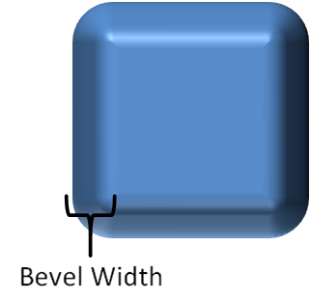  In this example, we see the width of an example bevel on a shape. end example]  The possible values for this attribute are defined by the ST_PositiveCoordinate simple type (§5.1.12.42).
The following XML Schema fragment defines the contents of this element:
<complexType name="CT_Bevel">
<attribute name="w" type="ST_PositiveCoordinate" use="optional" default="76200"/>
<attribute name="h" type="ST_PositiveCoordinate" use="optional" default="76200"/>
<attribute name="prst" type="ST_BevelPresetType" use="optional" default="circle"/>
</complexType>

