ST_PresetCameraType (Preset Camera Type)
These enumeration values represent different algorithmic methods for setting all camera properties, including position. The following example images below are all based off the following shape:
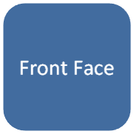
In this image, we can see the shape has a camera pointing directly at the front face.
This simple type's contents are a restriction of the XML Schema token datatype.
The following are possible enumeration values for this type:
Enumeration Value | Description
isometricBottomDown (Isometric Bottom Down) | [Example: Consider the following example of the camera preset type:  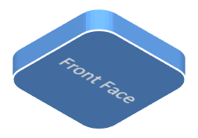  end example]
isometricBottomUp (Isometric Bottom Up) | [Example: Consider the following example of the camera preset type:  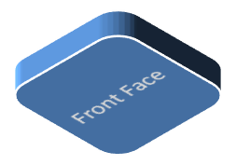  end example]
isometricLeftDown (Isometric Left Down) | [Example: Consider the following example of the camera preset type:  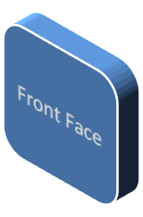  end example]
isometricLeftUp (Isometric Left Up) | [Example: Consider the following example of the camera preset type:  end example]
isometricOffAxis1Left (Isometric Off Axis 1 Left) | [Example: Consider the following example of the camera preset type:  end example]
isometricOffAxis1Right (Isometric Off Axis 1 Right) | [Example: Consider the following example of the camera preset type:  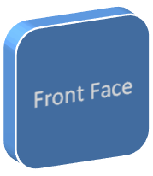  end example]
isometricOffAxis1Top (Isometric Off Axis 1 Top) | [Example: Consider the following example of the camera preset type:  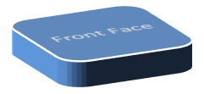  end example]
isometricOffAxis2Left (Isometric Off Axis 2 Left) | [Example: Consider the following example of the camera preset type:  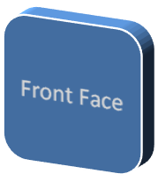  end example]
isometricOffAxis2Right (Isometric Off Axis 2 Right) | [Example: Consider the following example of the camera preset type:  end example]
isometricOffAxis2Top (Isometric Off Axis 2 Top) | [Example: Consider the following example of the camera preset type:  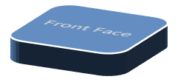  end example]
isometricOffAxis3Bottom (Isometric Off Axis 3 Bottom) | [Example: Consider the following example of the camera preset type:  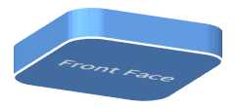  end example]
isometricOffAxis3Left (Isometric Off Axis 3 Left) | [Example: Consider the following example of the camera preset type:  end example]
isometricOffAxis3Right (Isometric Off Axis 3 Right) | [Example: Consider the following example of the camera preset type:  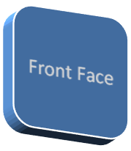  end example]
isometricOffAxis4Bottom (Isometric Off Axis 4 Bottom) | [Example: Consider the following example of the camera preset type:  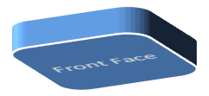  end example]
isometricOffAxis4Left (Isometric Off Axis 4 Left) | [Example: Consider the following example of the camera preset type:  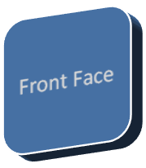  end example]
isometricOffAxis4Right (Isometric Off Axis 4 Right) | [Example: Consider the following example of the camera preset type:  end example]
isometricRightDown (Isometric Right Down) | [Example: Consider the following example of the camera preset type:  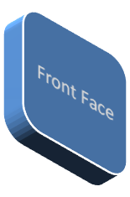  end example]
isometricRightUp (Isometric Right Up) | [Example: Consider the following example of the camera preset type:  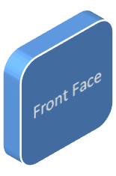  end example]
isometricTopDown (Isometric Top Down) | [Example: Consider the following example of the camera preset type:  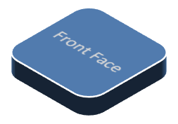  end example]
isometricTopUp (Isometric Top Up) | [Example: Consider the following example of the camera preset type:  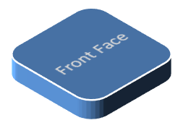  end example]
legacyObliqueBottom (Legacy Oblique Bottom) | [Example: Consider the following example of the camera preset type:  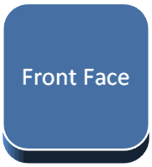  end example]
legacyObliqueBottomLeft (Legacy Oblique Bottom Left) | [Example: Consider the following example of the camera preset type:  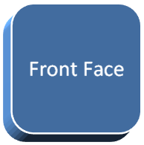  end example]
legacyObliqueBottomRight (Legacy Oblique Bottom Right) | [Example: Consider the following example of the camera preset type:  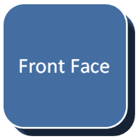  end example]
legacyObliqueFront (Legacy Oblique Front) | [Example: Consider the following example of the camera preset type:  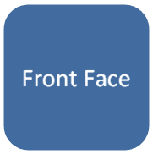  end example]
legacyObliqueLeft (Legacy Oblique Left) | [Example: Consider the following example of the camera preset type:  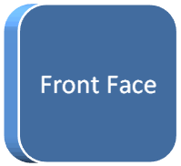  end example]
legacyObliqueRight (Legacy Oblique Right) | [Example: Consider the following example of the camera preset type:  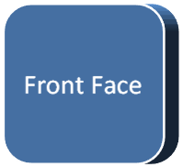  end example]
legacyObliqueTop (Legacy Oblique Top) | [Example: Consider the following example of the camera preset type:  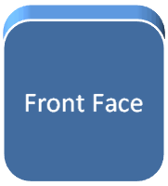  end example]
legacyObliqueTopLeft (Legacy Oblique Top Left) | [Example: Consider the following example of the camera preset type:  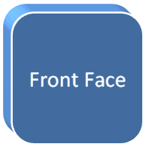  end example]
legacyObliqueTopRight (Legacy Oblique Top Right) | [Example: Consider the following example of the camera preset type:  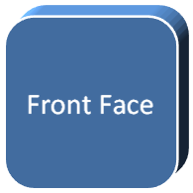  end example]
legacyPerspectiveBottom (Legacy Perspective Bottom) | [Example: Consider the following example of the camera preset type:  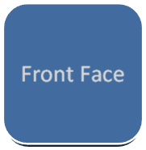  end example]
legacyPerspectiveBottomLeft (Legacy Perspective Bottom Left) | [Example: Consider the following example of the camera preset type:  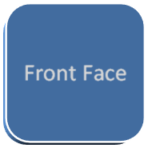  end example]
legacyPerspectiveBottomRight (Legacy Perspective Bottom Right) | [Example: Consider the following example of the camera preset type:  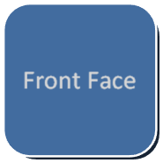  end example]
legacyPerspectiveFront (Legacy Perspective Front) | [Example: Consider the following example of the camera preset type:  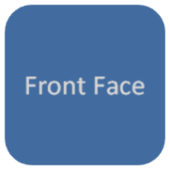  end example]
legacyPerspectiveLeft (Legacy Perspective Left) | [Example: Consider the following example of the camera preset type:  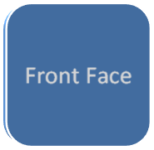  end example]
legacyPerspectiveRight (Legacy Perspective Right) | [Example: Consider the following example of the camera preset type:  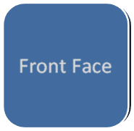  end example]
legacyPerspectiveTop (Legacy Perspective Top) | [Example: Consider the following example of the camera preset type:  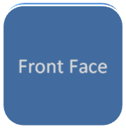  end example]
legacyPerspectiveTopLeft (Legacy Perspective Top Left) | [Example: Consider the following example of the camera preset type:  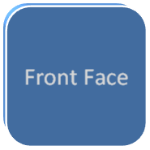  end example]
legacyPerspectiveTopRight (Legacy Perspective Top Right) | [Example: Consider the following example of the camera preset type:  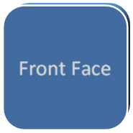  end example]
obliqueBottom (Oblique Bottom) | [Example: Consider the following example of the camera preset type:  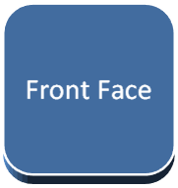  end example]
obliqueBottomLeft (Oblique Bottom Left) | [Example: Consider the following example of the camera preset type:  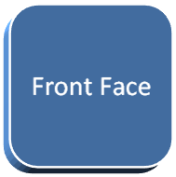  end example]
obliqueBottomRight (Oblique Bottom Right) | [Example: Consider the following example of the camera preset type:  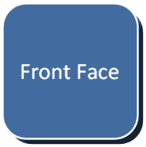  end example]
obliqueLeft (Oblique Left) | [Example: Consider the following example of the camera preset type:  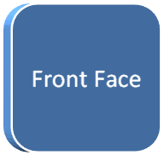  end example]
obliqueRight (Oblique Right) | [Example: Consider the following example of the camera preset type:  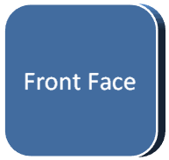  end example]
obliqueTop (Oblique Top) | [Example: Consider the following example of the camera preset type:  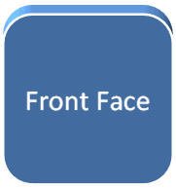  end example]
obliqueTopLeft (Oblique Top Left) | [Example: Consider the following example of the camera preset type:  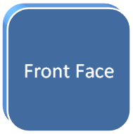  end example]
obliqueTopRight (Oblique Top Right) | [Example: Consider the following example of the camera preset type:  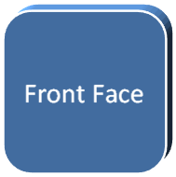  end example]
orthographicFront (Orthographic Front) | [Example: Consider the following example of the camera preset type:  end example]
perspectiveAbove (Orthographic Above) | [Example: Consider the following example of the camera preset type:  end example]
perspectiveAboveLeftFacing (Perspective Above Left Facing) | [Example: Consider the following example of the camera preset type:  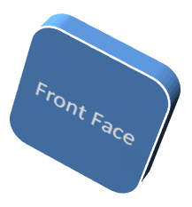  end example]
perspectiveAboveRightFacing (Perspective Above Right Facing) | [Example: Consider the following example of the camera preset type:  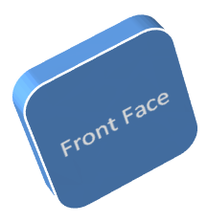  end example]
perspectiveBelow (Perspective Below) | [Example: Consider the following example of the camera preset type:  end example]
perspectiveContrastingLeftFacing (Perspective Contrasting Left Facing) | [Example: Consider the following example of the camera preset type:  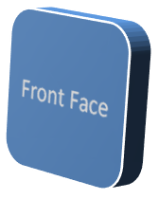  end example]
perspectiveContrastingRightFacing (Perspective Contrasting Right Facing) | [Example: Consider the following example of the camera preset type:  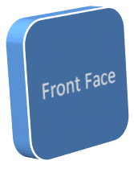  end example]
perspectiveFront (Perspective Front) | [Example: Consider the following example of the camera preset type:  end example]
perspectiveHeroicExtremeLeftFacing (Perspective Heroic Extreme Left Facing) | [Example: Consider the following example of the camera preset type:  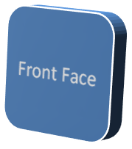  end example]
perspectiveHeroicExtremeRightFacing (Perspective Heroic Extreme Right Facing) | [Example: Consider the following example of the camera preset type:  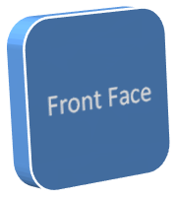  end example]
perspectiveHeroicLeftFacing (Perspective Heroic Left Facing) | [Example: Consider the following example of the camera preset type:  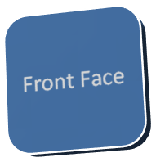  end example]
perspectiveHeroicRightFacing (Perspective Heroic Right Facing) | [Example: Consider the following example of the camera preset type:  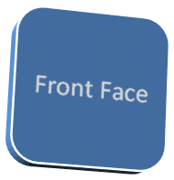  end example]
perspectiveLeft (Perspective Left) | [Example: Consider the following example of the camera preset type:  end example]
perspectiveRelaxed (Perspective Relaxed) | [Example: Consider the following example of the camera preset type:  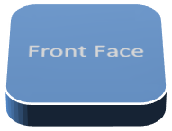  end example]
perspectiveRelaxedModerately (Perspective Relaxed Moderately) | [Example: Consider the following example of the camera preset type:  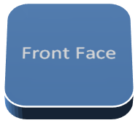  end example]
perspectiveRight (Perspective Right) | [Example: Consider the following example of the camera preset type:  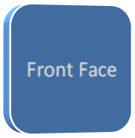  end example]

Referenced By
camera@prst (§5.1.7.5)
The following XML Schema fragment defines the contents of this simple type:
<simpleType name="ST_PresetCameraType">
<restriction base="xsd:token">
<enumeration value="legacyObliqueTopLeft"/>
<enumeration value="legacyObliqueTop"/>
<enumeration value="legacyObliqueTopRight"/>
<enumeration value="legacyObliqueLeft"/>
<enumeration value="legacyObliqueFront"/>
<enumeration value="legacyObliqueRight"/>
<enumeration value="legacyObliqueBottomLeft"/>
<enumeration value="legacyObliqueBottom"/>
<enumeration value="legacyObliqueBottomRight"/>
<enumeration value="legacyPerspectiveTopLeft"/>
<enumeration value="legacyPerspectiveTop"/>
<enumeration value="legacyPerspectiveTopRight"/>
<enumeration value="legacyPerspectiveLeft"/>
<enumeration value="legacyPerspectiveFront"/>
<enumeration value="legacyPerspectiveRight"/>
<enumeration value="legacyPerspectiveBottomLeft"/>
<enumeration value="legacyPerspectiveBottom"/>
<enumeration value="legacyPerspectiveBottomRight"/>
<enumeration value="orthographicFront"/>
<enumeration value="isometricTopUp"/>
<enumeration value="isometricTopDown"/>
<enumeration value="isometricBottomUp"/>
<enumeration value="isometricBottomDown"/>
<enumeration value="isometricLeftUp"/>
<enumeration value="isometricLeftDown"/>
<enumeration value="isometricRightUp"/>
<enumeration value="isometricRightDown"/>
<enumeration value="isometricOffAxis1Left"/>
<enumeration value="isometricOffAxis1Right"/>
<enumeration value="isometricOffAxis1Top"/>
<enumeration value="isometricOffAxis2Left"/>
<enumeration value="isometricOffAxis2Right"/>
<enumeration value="isometricOffAxis2Top"/>
<enumeration value="isometricOffAxis3Left"/>
<enumeration value="isometricOffAxis3Right"/>
<enumeration value="isometricOffAxis3Bottom"/>
<enumeration value="isometricOffAxis4Left"/>
<enumeration value="isometricOffAxis4Right"/>
<enumeration value="isometricOffAxis4Bottom"/>
<enumeration value="obliqueTopLeft"/>
<enumeration value="obliqueTop"/>
<enumeration value="obliqueTopRight"/>
<enumeration value="obliqueLeft"/>
<enumeration value="obliqueRight"/>
<enumeration value="obliqueBottomLeft"/>
<enumeration value="obliqueBottom"/>
<enumeration value="obliqueBottomRight"/>
<enumeration value="perspectiveFront"/>
<enumeration value="perspectiveLeft"/>
<enumeration value="perspectiveRight"/>
<enumeration value="perspectiveAbove"/>
<enumeration value="perspectiveBelow"/>
<enumeration value="perspectiveAboveLeftFacing"/>
<enumeration value="perspectiveAboveRightFacing"/>
<enumeration value="perspectiveContrastingLeftFacing"/>
<enumeration value="perspectiveContrastingRightFacing"/>
<enumeration value="perspectiveHeroicLeftFacing"/>
<enumeration value="perspectiveHeroicRightFacing"/>
<enumeration value="perspectiveHeroicExtremeLeftFacing"/>
<enumeration value="perspectiveHeroicExtremeRightFacing"/>
<enumeration value="perspectiveRelaxed"/>
<enumeration value="perspectiveRelaxedModerately"/>
</restriction>
</simpleType>

