ST_HierBranchStyle (Hierarchy Branch Style Definition)
This simple type specifies the possible values for the branch style of a hierarchy diagram.
This simple type's contents are a restriction of the XML Schema token datatype.
The following are possible enumeration values for this type:
Enumeration Value | Description
hang (Hanging) | The branch style is hanging from the parent.  [Example: Consider the following image as an example of a hanging branch style:  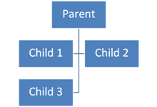  end example]
init (Initial) | This means that the value has not been set.
l (Left) | The branch style falls off the left.  [Example: Consider the following image as an example of a left hanging branch style:  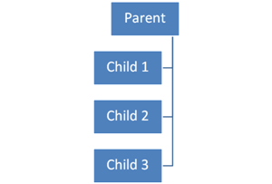  end example]
r (Right) | The branch style falls off the right.  [Example: Consider the following image as an example of a right hanging branch style:  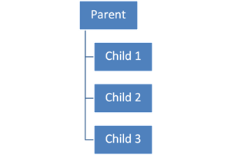  end example]
std (Standard) | The standard branch style is to be used.  [Example: Consider the following image as an example of a standard hanging branch style:  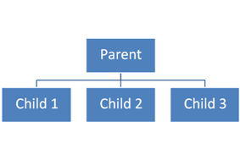  end example]

Referenced By
hierBranch@val (§5.9.6.7); ST_FunctionValue (§5.9.7.32)
The following XML Schema fragment defines the contents of this simple type:
<simpleType name="ST_HierBranchStyle" final="restriction">
<restriction base="xsd:token">
<enumeration value="l"/>
<enumeration value="r"/>
<enumeration value="hang"/>
<enumeration value="std"/>
<enumeration value="init"/>
</restriction>
</simpleType>

