ST_ClrAppMethod (Color Application Method Type)
This type defines the way a given set of colors is applied to a set of nodes or items across a diagram.
This simple type's contents are a restriction of the XML Schema token datatype.
The following are possible enumeration values for this type:
Enumeration Value | Description
cycle (Cycle) | The colors will apply from A to B to A if A and B were the colors present.  [Example: Consider the following image as an example of cycle applied to a diagram:  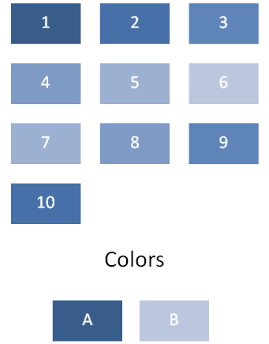  In this example, the color A is applied to node 1 and node 10. Color B is considered the node color between A and A across the diagram. Colors interpolate across the diagram from A to B back to A. end example]
repeat (Repeat) | The colors will apply from A through B to A through B if A through B were the colors present.  [Example: Consider the following image as an example of repeat applied to a diagram:  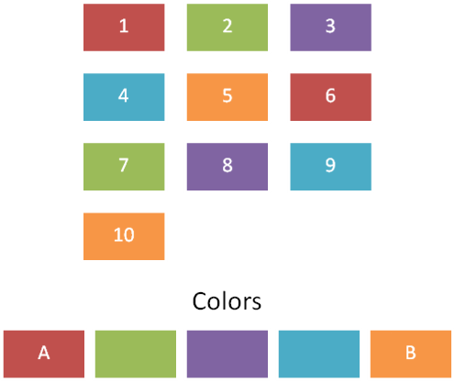  In this example, the color A is applied to node 1, the next color to node 2, and so on through color B, then this coloring is repeated until there are no more nodes to color. end example]
span (Span) | The colors will interpolate from A to B across the entire diagram if A and B were the colors present.  [Example: Consider the following image as an example of span applied to a diagram:  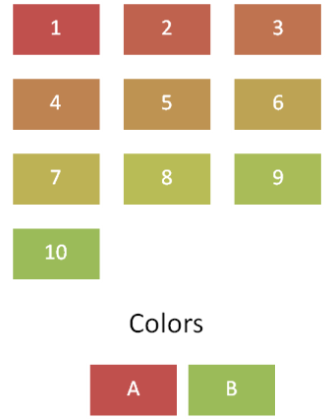  In this example, the color A is applied to node 1, the color B is applied to node 10 and the colors applied to nodes 2 through 9 are interpolated between colors A and B. end example]

Referenced By
effectClrLst@meth (§5.9.4.7); fillClrLst@meth (§5.9.4.8); linClrLst@meth (§5.9.4.9); txEffectClrLst@meth (§5.9.4.12); txFillClrLst@meth (§5.9.4.13); txLinClrLst@meth (§5.9.4.14)
The following XML Schema fragment defines the contents of this simple type:
<simpleType name="ST_ClrAppMethod">
<restriction base="xsd:token">
<enumeration value="span"/>
<enumeration value="cycle"/>
<enumeration value="repeat"/>
</restriction>
</simpleType>

